

TimeVision Plus User
Guide Version 5.2

Introduction
TimeVision Plus is a simple Windows based Time & Attendance system, that uses a Paradox local or network shared database. It can use multiple clock terminals, have more than 1 concurrent user, be installed on more than one PC, and handle up to about 200 employees. It also has a basic Calendar for booking absences. 12 Schedules & Groups and allow for 3 breaks & 6 different rates. There is an optional Sage payroll link available.

Main Menu

When you first launch TimeVision Plus, you’ll be greeted by the following screen.
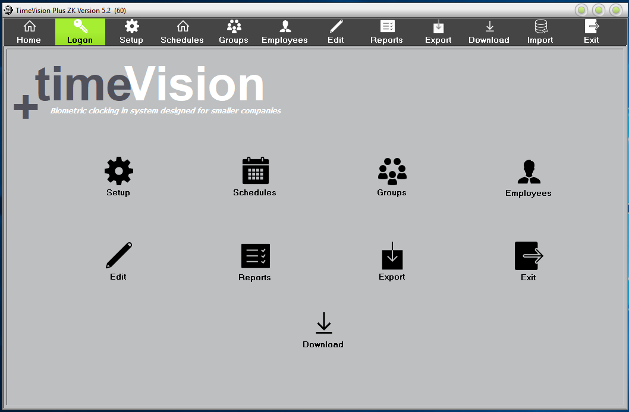

Along the top, you’ll see a series of icons:
These icons each have different functions, listed below (from left to right):

- Logon/Logoff – This allows you to log on or log off.

- Setup – This allows you to configure TimeVision Plus’s setup and gives you the ability to backup and restore data.

- Schedules – This allows you to configure shifts for your employees, and specify their start time, finish time and breaks, etc.

- Groups – This allows you to assign any schedules you have created to your employees.

- Employees – This allows you to create, edit and/or delete any employees on your database. Plus, access to the Calendar.

- Edit – This allows you to view when employees clock in/out, the day and date, what rate they are being paid for their hours worked, and any error codes or anomalies.

- Reports – This allows you to view several reports based on the data gathered (e.g. “Absence Report”).

- Export – This allows you to export the clocking data into a CSV file or directly to your Sage payroll system.

- Download – Option to download your clocking data from your clock terminals either over the network or by using a USB Memory stick (Pen drive).

- Import - This allows you on setup to import new Employee data from a CSV file.

- Exit – This will exit the application.

You can select these options by clicking on these icons across the top, or the select icons on the main home page.

To log in to TimeVision Plus, click the “Logon” button.

This will take you to the following screen, where you will need to select your TimeVision Plus username in the “User Name” list, and then type your password in the “Password” field. (Not your windows Logon credentials.)

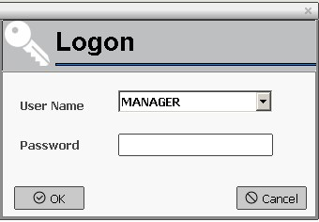
By default, the username is “Manager” and there is no password.
We recommend that you change this ASAP for security purposes and to avoid unwanted changes to your data.

Setup

This is where you can make changes to the TimeVision Plus software. The first section is “User Setup”.
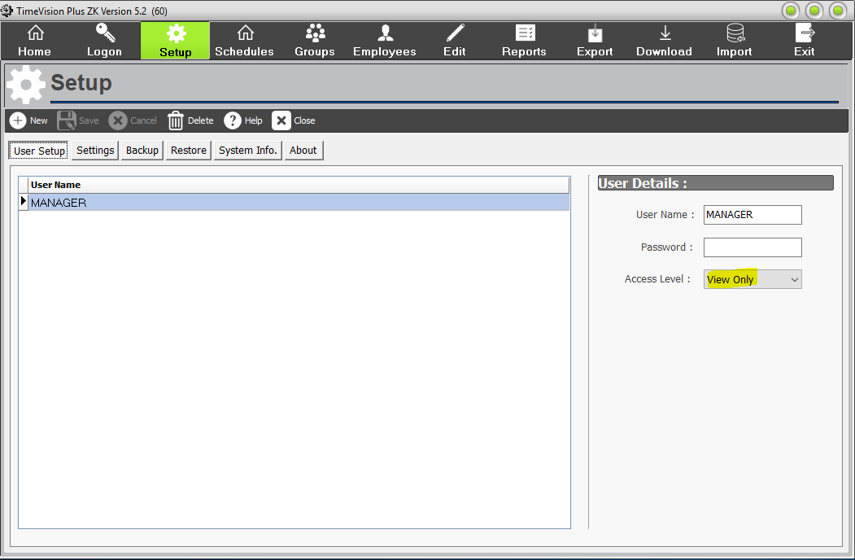

This is where you can add and remove users from the system. You need to assign a username, password and access level to each user. There are two access levels that can be assigned to new users:
- Edit – This gives the user full control of the system.

- View Only – This allows the user to view data and run reports, but they will not be able to change anything. By default, this is the normal setting, you need to change it to “Edit”, to make any changes.

If no users are defined, everyone can use the system and change the data, so it’s highly recommended that at least one user is defined for security reasons.

When assigning a password to a user, the password length is limited to 10 characters, but can include a mixture of numbers and letters. Please note that passwords are case sensitive.

The next section is “Settings”.

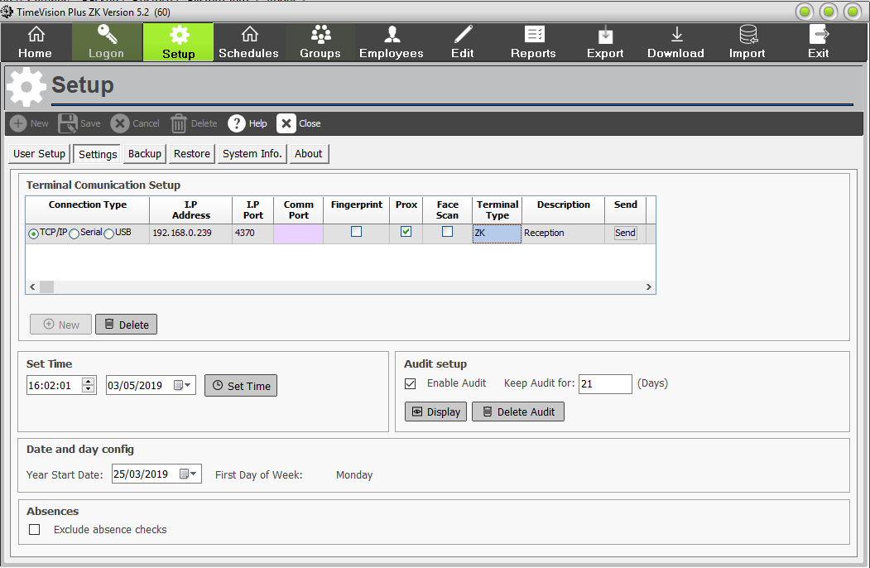

“Terminal Communication Setup” will allow you to add a clock to the system (though this may have already been done for you). There are two ways of doing this – through TCP/IP or Serial.

- TCP/IP – This allows the clock to be accessed over a network. The default IP address is 192.168.0.200, and the default port is 4370 for ZK & UK clocks. Older clocks may have a different Port number, ask Computime technical support

You may change the IP address for your convenience, but you will need to change the IP address at the terminal as well. You can not use DHCP addresses, or Wi-fi.

- Serial – This allows the clock to be connected directly to the PC via a RS-232 cable. If this is the method used, you will need to select that the COMM Port is being used. This is usually for older clock terminals.
- USB – Data is transferred from the clock to the PC & TimeVision Plus, by a standard USB memory stick* (pen drive), when there is no network connection.
(*=Not encrypted, password protected or locked. FAT32)

You also need to select the correct clock type from the pull-down menu. (ZK, Anviz or UK), as TimeVision Plus can deal with different make & model clock terminals. The number of terminals you can use with TimeVision Plus, is dependent on your software licence.

Select Face scanner, Fingerprint or Proximity terminals, by selecting the relevant tick box. If you have more than one clock terminal, it is recommended you add in the description field, the clock’s location. E.g. Reception, Warehouse, Gatehouse, etc.

Then Save these settings.

If your clock terminal(s) is/are connected across the network, you can update the information on the clock(s) using the ‘Send’ button.

You can also “Set Time”. This will change the time and date of the clocking terminal.

“Audit Setup” will allow you to create audit files – these will give details of any changes to the system, e.g. editing data, entering the setup screen. The audit will enable you to keep track and monitor which buttons and options have been enabled. If you have defined System Users, the audit will also show who was logged in at the time. If you do not wish to record this data, uncheck “Enable Audit”.

Clicking “Display” will bring up the audit report if “Enable Audit” is checked. The information in the audit includes:

- The time the action took place.
- The computer used when the action took place.
- Which user performed the action.
- The action, e.g. “clicked on Logon button”

If you wish to keep an audit, from here you can specify how long the recorded data should be kept for. You can also display an audit or delete any currently stored audit data.

You are also able to configure the “Date and Day”. This will default as the day the system was installed but can be changed. It will also affect which day the system considers to be the first day of the week. We recommend you change this to reflect the first day of your working week.

Absences:
If you wish to exclude Absence checks (ABS) from the list of errors, tick this box, here.

The next section is “Backup”.

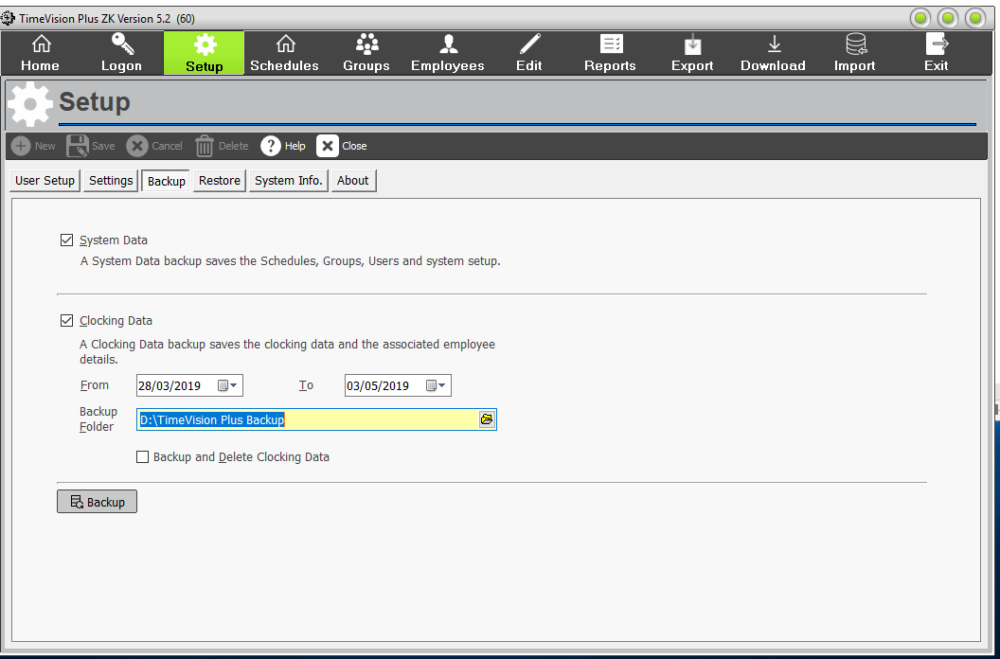

This allows you to save a copy of your data that can be used later to recover any lost or corrupted data.

Important: You should backup your data on a regular basis in case of any problems that could corrupt or destroy your data. This backed up data can easily be restored using the ‘Restore’ function within TimeVision Plus.

There are two different types of backup that are supported by TimeVision Plus; ‘System Data’ and ‘Clocking Data’.

- “System Data” will create a backup of your schedules, groups, registered users and your general system setup which will be saved to the specified folder.

- “Clocking Data” will create a copy of all your clocking data (between two specified dates) and any associated employee data which will be saved to the specified folder.

Important: We recommend storing any backup data on a removable media such as CD, USB stick or a network drive. It is also advisable that a copy of your backup should be taken offsite regularly in case of fire, theft, or Cyber-attack.

The “Backup and Delete Clocking Data” option will allow you to back up the clocking data and then delete it from the current data. (This data can then be recovered at any time using the “Restore” option).

To back up your data, all you need to do is click the “Backup” button.
Note: If your TimeVision Plus, has its database on a network share on the server. Your IT may include this location as part of their regular server/network backup routine. Check with them.
If this is the case, they should be able to restore the database too.
The next section is “Restore”.
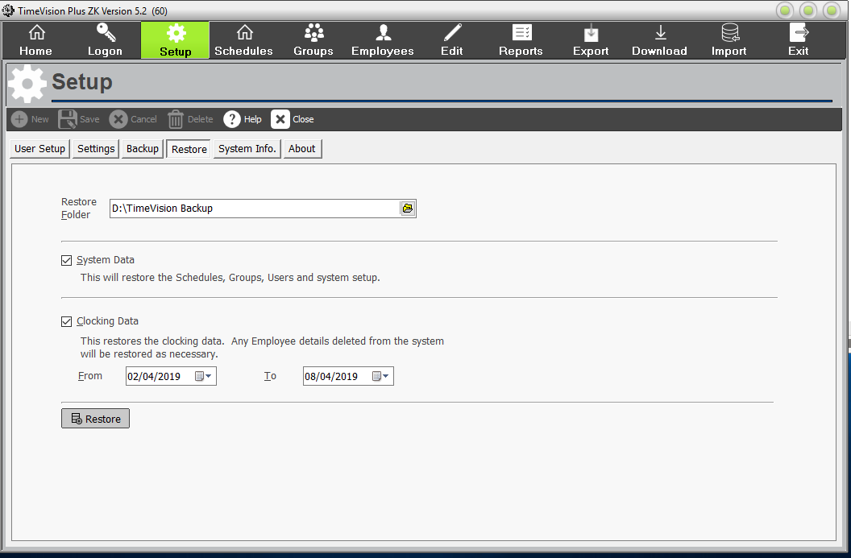
This allows you to retrieve any previously backed up data. This is mostly used in case of data corruption, or if any data is lost.

“Restore Folder” allows you to tell the system where the backup you saved is kept, so you can restore the data saved in the backup.

This allows you to select which data should be restored. If you have configured your Restore Folder correctly, the dates should have already been put in for you, though they can be edited as required.

To restore your data, all you need to do is click the “Restore” button.
The next section is “System Info.”

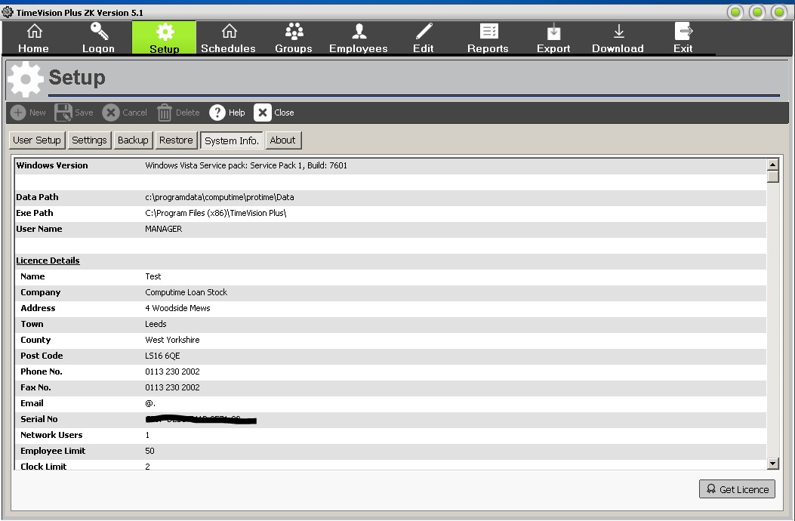
This provides you with information about your system setup, e.g. your database, data paths*, networking settings, serial number. If you contact the Support department, you may be asked for this information.
* If the TimeVision Plus database is stored on the local PC, by default it is usually in C:\programdata\computime\timevision plus\data.
If the TimeVision Plus database is on a network share, the location should be here. E.g. \\server01\TimeVision Plus\data
The “Get Licence” button is used to update the TimeVision Plus licence, online. if you change your employee limit, number of concurrent users, terminals or purchase the optional Sage Payroll link.
The next section is “About”.
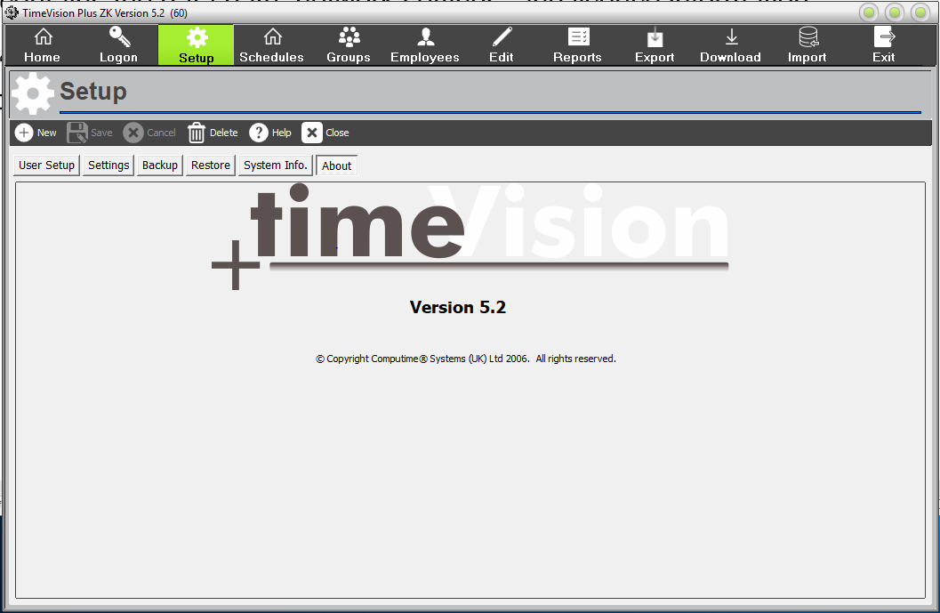
This tells you which version of TimeVision Plus you’re currently using. If you contact the Support department, you may be asked for this information.
Schedules To begin setting up shifts for your employees, click “Schedules” from the main menu.
Schedules are work patterns or shifts that are regularly worked by all or some of your staff. E.g. 09:00 to 17:00, 14:00 to 22:00.

To begin setting up shifts for your employees, click “Schedules” from the main menu. Then select “New” to start a new schedule or select an existing schedule from the pull-down list. In TimeVision Plus, you can have up to 12 schedules.
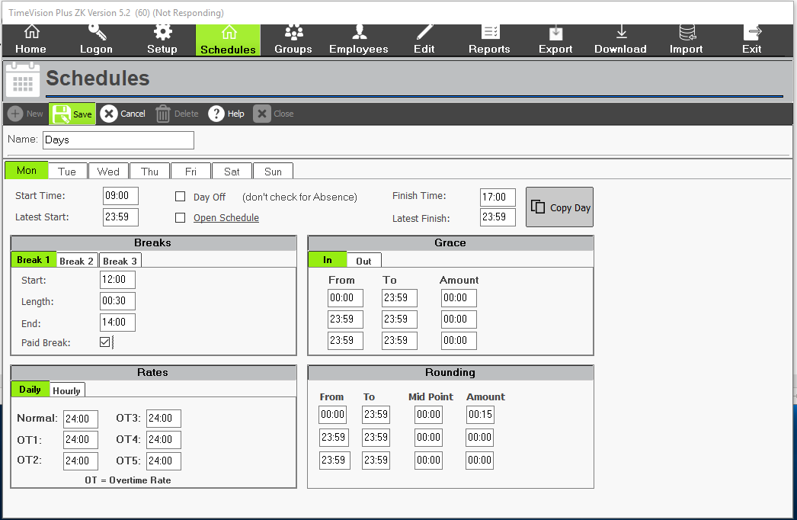
The “Start Time” and “Finish Time” allow you to specify when you would like the employee’s shift to start and finish. If they clock in after the time specified, they will be marked as ‘Late’ on the report.

The “Latest Start/Finish” field means that if the employee clocks in/out after the specified time, they will be moved to the next available shift. E.g. Start time: 09:00 and Latest Start: 09:30. Then if Ian starts today at 09:45, he will put on the next shift. Therefore, if the employee only works one shift a day, it’s recommended that the Latest Start/Finish value remains at 23:59.

Breaks:
In TimeVision Plus, you can up to 3 breaks in any one day, for any one schedule. These breaks can either be paid or unpaid. (Tick Paid break box as appropriate.)
The “Start”, “End” and “Length” fields allow you to specify when the employee’s lunch breaks are. E.g. They can have a 30-minute lunch break between 12:00 and 14:00 (see above Day schedule.)

The “Length” field allows you to specify how long the employee’s lunch break should be. This means that if the employee does not clock in/out for lunch, the lunch length you have specified will be automatically deducted from their hours worked. If an employee clocks in/out but takes longer than the allocated lunch length, the actual time they were clocked out for will be deducted.

“Grace Bands” allow you to specify times when an employee is allowed some leeway when clocking in. e.g. Maybe a queue for the clock machine, so you may allow a 3 minute grace period around clocking in time.

For example: An employee may have a start time of 08:00, but if they clock in up to 08:03 you still want to pay them from 08:00. This would be a grace band running from 08:00 to 08:03, of amount 00:03.

“Rounding” allows you to specify how you want your rounding to occur. When an employee clocks in, it will automatically round up – and when they clock out, it will automatically round down.

You can define three different bands throughout the days with differing rounding bands, as shown above. If you wanted to only pay your employees in 15-minute intervals, an example of how rounding works would be that if they clocked in at 08:05, it would round up to 08:15.

“Daily Rates” are used in defining how the hours worked in a day are split.

For example: If you wanted to pay the first 7 hours at Normal rate, the next hour at Overtime 1 and the next two hours at Overtime 2 – you would set Normal to 07:00, Overtime 1 to 01:00 and Overtime 2 to 02:00.

“Day Off” and “Open Schedule” are the final sections of ‘Schedule’.

“Day Off” allows you to record when an employee is not expected to work.

This should not be checked if an employee is absent – this function is specifically for when the employee has a day that they are not scheduled to work.

Below is an example of a standard 09:00-17:00 shift (with a 45-minute lunch break):
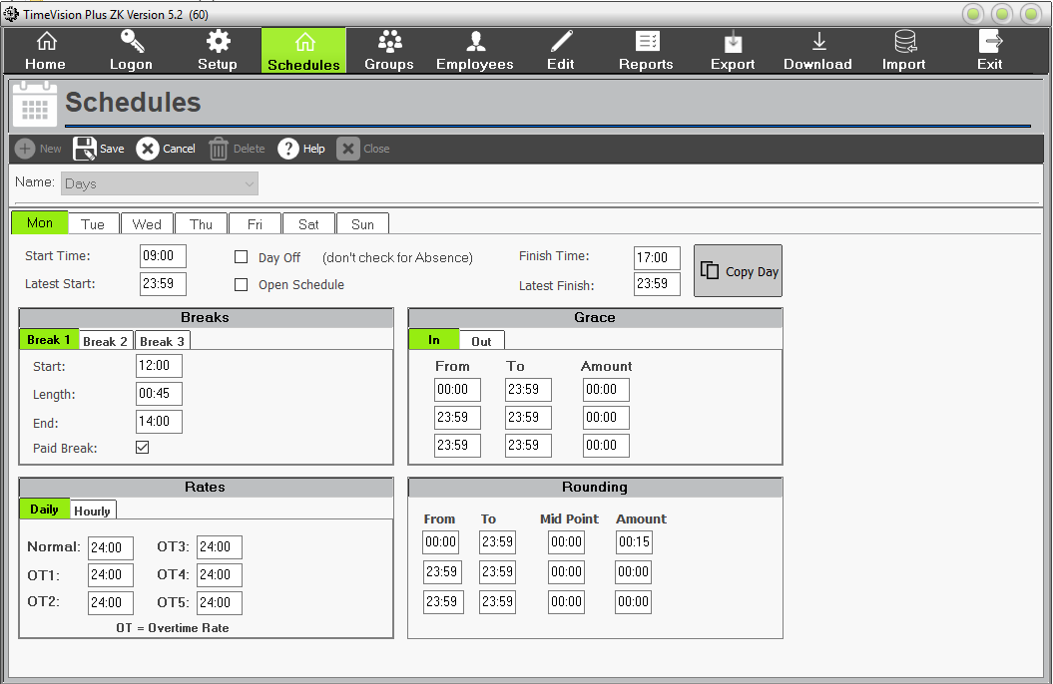

Night Shifts (including shifts that go beyond midnight (next day))
To record shifts that go beyond midnight into the next day, we had added 24 hours to the Finish times.
For example:
Night shift from 10pm to 6 am, next morning. Would be recorded as:
Start Time: 22:00. Finish Time: 30:00 (6 hrs + 24 hrs).
See schedule that follows, with a half an hour paid lunchbreak between 2am & 3am.
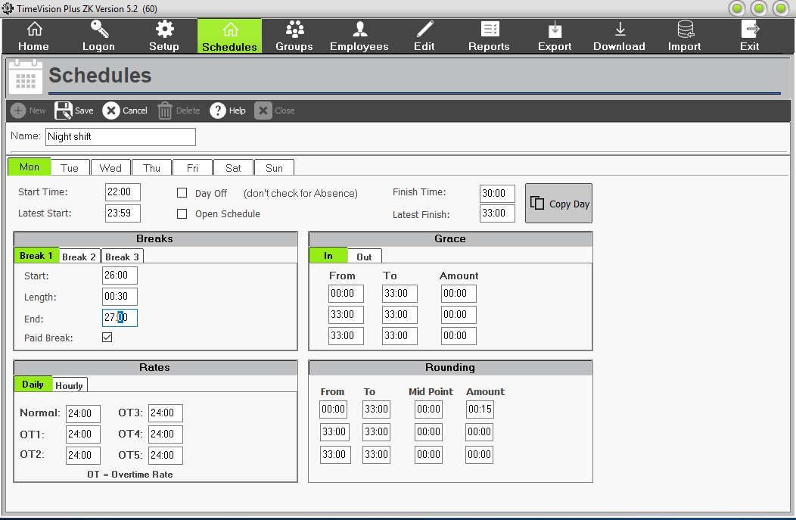
“Open Schedule” allows you to create a schedule with no fixed start time.
This means that an employee can never be flagged as late, because clicking ‘Open Schedule’ means that the “Start Time” and “Latest Finish” boxes will be disabled. In TimeVision Plus, the shift can finish after midnight. E.g. staff finishing at 3am (27:00) in the morning.
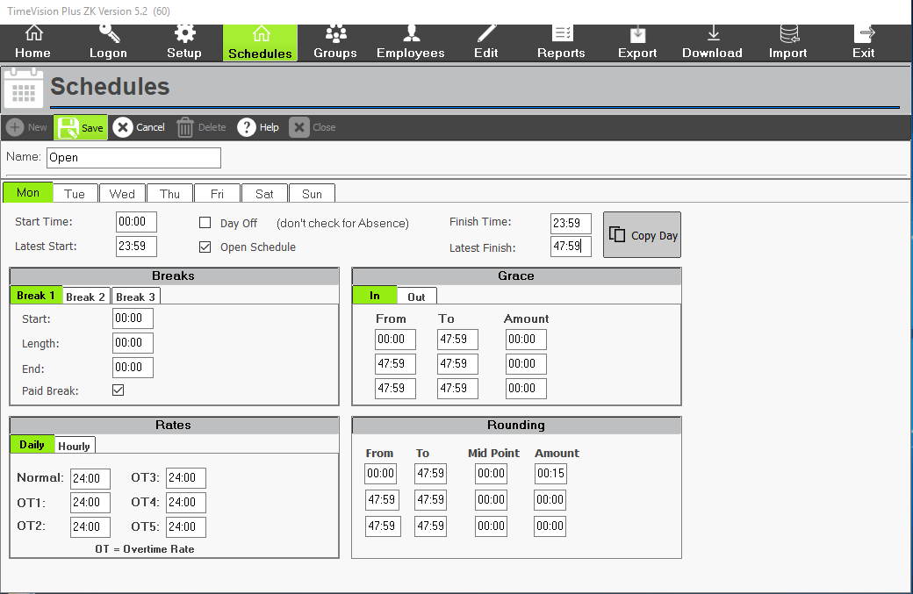
Once you have done the first day, you can copy that day, to some or all the remaining days of that week, by clicking on the “Copy Day” button.
When finished, remember to click on the “Save” button.

Groups
To begin setting up groups for your employees, click “Groups” from the main menu.

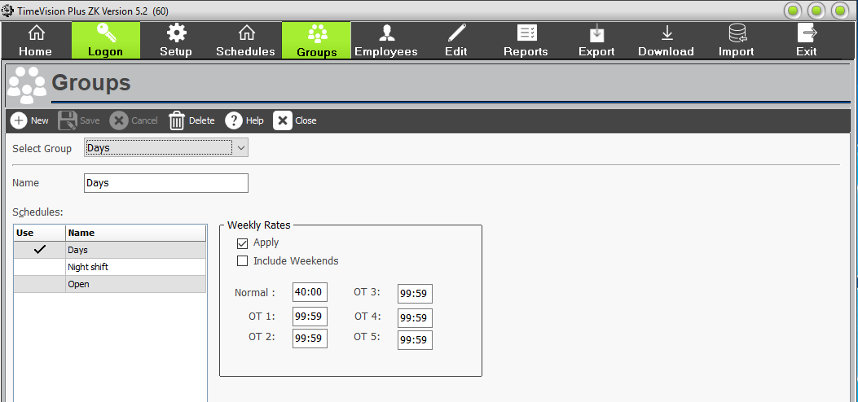

Groups allow you to group schedules together. E.g. Early shift, Late Shift. TimeVision Plus will work out what associated schedule staff have worked, from their start and finish clocking times.
To set up a new group, click “New”.
It’s also possible to specify weekly overtime rules for individual groups.
For example: If an employee must work 40 hours in a week before they can earn overtime, this can be arranged through the weekly overtime rules. It is also possible to specify whether any hours worked at the weekend can be used to make up for any shortfalls in weekday hours.

When you’re done making changes, click “Save”. The new group you have assigned will now be shown – clicking on it will show you which schedules are currently assigned to that group.

You can have a maximum of 12 groups in TimeVision Plus.

These Groups can then be assigned to your existing staff in the Employee Tab, or when you create new employees.

Employees
Start by clicking “Employees” from the main menu.
You can then browse existing employees and make any required amendments, or If you need to add a new employee to your database, click on “New”.

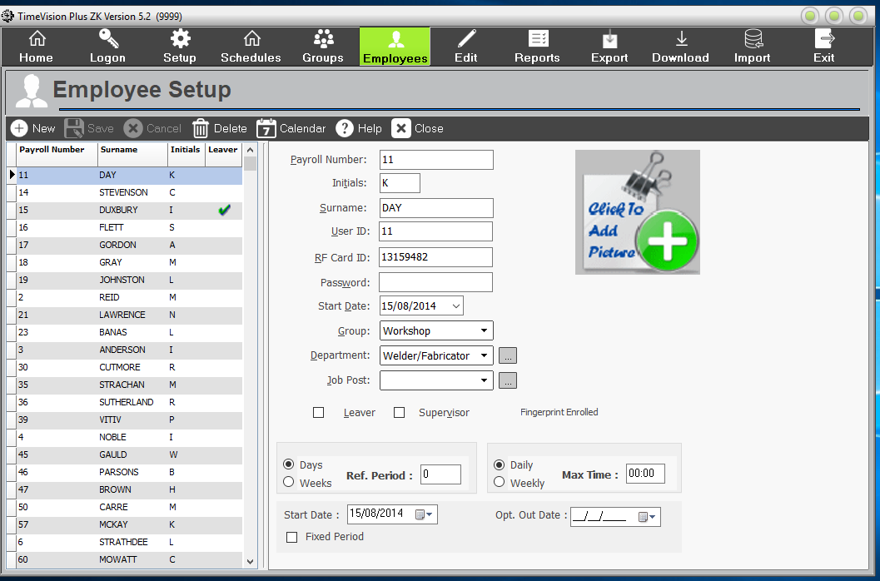

Now, you’ll need to enter the details of your new employee.
Payroll Number: Compulsory field. It is recommended you use their actual payroll number, if you plan now or in the future link it with Sage Payroll or another payroll software.
Initials & Surname: Compulsory fields.
User ID: Compulsory field. This number can be the same as their payroll number. It must however not contain any leading zeros or letters, be below 65,000 and be unique.
RF Card ID: if using RFID cards or fobs, enter the number here. Must not contain any leading zeros. Usually 7 or 8 digits.
Password: You can use optional passwords of 4 numbers. (At the clock, when you clock in/out, you would enter the User ID number, then the password when prompted.)
Start Date: Compulsory field. Changes happen at midnight, so if the start date is today, use yesterday’s date.
Group: If you are using groups & schedules, enter the group name from the pull-down list. You can only be a member of one group.
Department: Voluntary. You can set create new departments here (click on box to the side) and make staff members of them here from the pull-down list.
Job Post: Voluntary. You can set create new job posts here (click on box to the side) and make staff members of them here from the pull-down list.
Photo: If you are using a Face scanner have taken a photo on it, this will appear here. You can also browse to a photo of the employee if there is one on the PC or network.
You’ll notice that this will also enable you to state whether they are a Leaver or a Supervisor. If you are using a finger or face scanner terminal, and the member of staff has registered their fingerprint/face, you should get message that the face/fingerprint enrolled.
The next section only needs completing if the member of staff is going to be using the Working Time Directive (WTD).

Edit Data
To review the clocking data downloaded from your clocking terminal (and make any necessary changes), click “Edit” from the main menu. Note, to see any clocking data for a given period, you must have previously downloaded the data from the clock into TimeVision Plus. Either across the network or by USB. See Download.
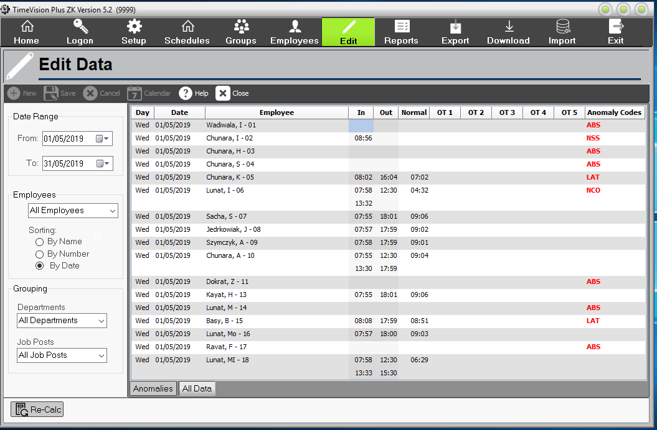

This section allows you to view and edit data downloaded from the clocking terminal. You can amend the clocking times and hours worked for a day, and/or change codes used, e.g. ABS to SIC, or remove a LAT code.

By default, this screen will show the last seven days’ worth of clocking data, but you can change which dates are shown by using the “Date Range” on the left. You can also filter the data further to view a single employee, or group employees shown by Department and/or Job Post.

There are two main pages on this screen: Anomalies and All Data.

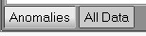

The ‘All Data’ page shows all clocking data for the dates/employees selected.

The ‘Anomalies’ page will only show days with anomalous clocking’s (e.g.
employees flagged as late, absent, those who haven’t clocked out).

If you highlight an anomaly on the ‘Anomalies’ screen and click “Accept”, this anomaly will be removed from the Anomalies page. It will, however, still be viewable from the ‘All Data’ page.
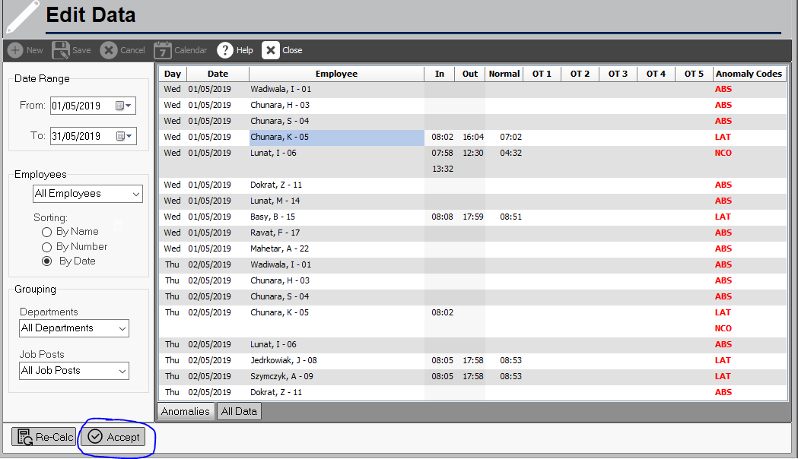

You can amend any existing clocking data, by typing over the existing clocking times.
Press the “Re-Calc” button.
The system will recalculate that selected employee’s Normal/Overtime hours for the highlighted day. Font will be in bold.
Save the changes afterwards. Font will now be normal.
If an employee has no clocking’s for that day i.e. Not clocked in and out, and you wish to add hours, you need to create a day for them.
Press the “AltGr”+”P” together, on the keyboard
Right click in the Edit screen and select Create a day.
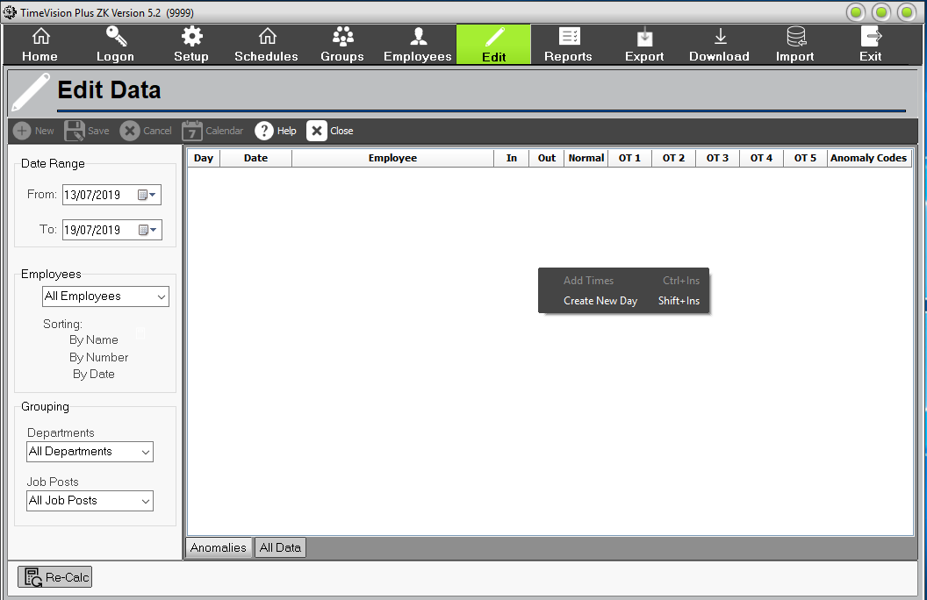
Enter the date (and will work out the day from the date.)
Select their name from the pull-down list.
Enter their start and finish times.
Click on the “Re-Calc” button.
Select schedule from pull down list. Ok. (font will be in bold, until saved.)
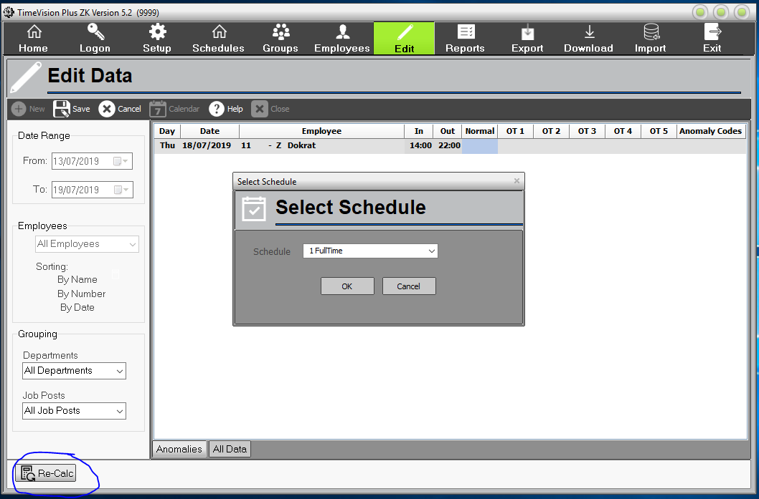
Then save changes. (font will appear normal)

Reports
There are eight types of reports offered by TimeVision Plus:
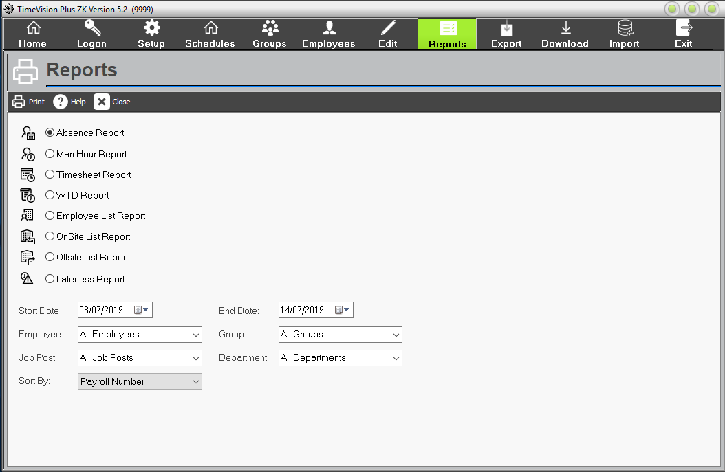

- Absence Report – This allows you to print a list of absences between two dates for a range of employees. (This will cover four different types of absence – Holiday, Bank Holiday, Sickness and Absence). You can specify which type of absence be printed on the report.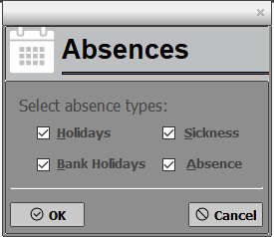

- Employee List – This will allow you to print a list of the employees defined in the system. You can print an individual group or all employees.

- Man Hour Report – This will allow you to print a list of employees and the total hours worked by each employee.

- Onsite / Offsite List – This will allow you to print a list of all employees who are showing as being onsite or offsite. (Important: Please note that TimeVision Plus is not a real time system and will only show the status at the time the clocks were downloaded).

- Timesheet Report – This will allow you to print a timesheet for the selected employees. The timesheet will provide a list of the clocking times and hours for each day.

- Lateness Report – This will allow you to print a list of lateness’s within a specified period.

- WTD Report – This will allow you to print a report of the average number of hours an employee has worked as set up on the Working Time Screen, in the Employee Tab.

To print a report, you need to select the one you require (by clicking on it) and, if necessary, specify the dates of the report. You can also specify which employees or groups should be included in the report and can choose how to sort the employees in the report.

When you’re ready to print the report, click “Print”. This will enable you to configure where and how the report should be sent. If you want a physical copy of the report, click on Ok” then on Report Destination click on Printer. This will send it to the selected printer (in this case is Samsung ML -331).

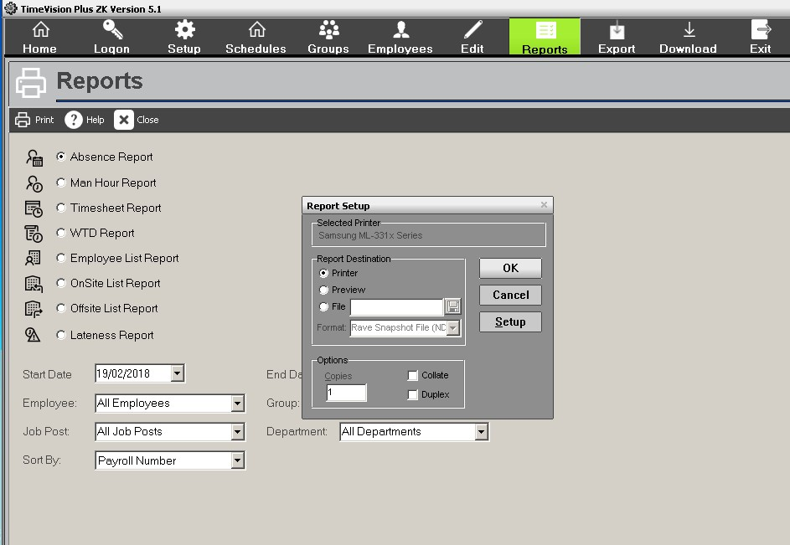

If you want to see what the report will look like before you print or save it, click
“Preview”.

If you want to save the report as a file rather than print a hard copy of it, click “File” and choose where you would like the report to be saved, and which format you prefer. You can also print it to a PDF/XPS document printer, depending on what version of Windows & Office you have.

Export
The “Export” feature allows you to generate a CSV or Sage payroll file (if you have the Sage payroll software installed). In order to generate one of these files, you need to click “Export” from the main menu.

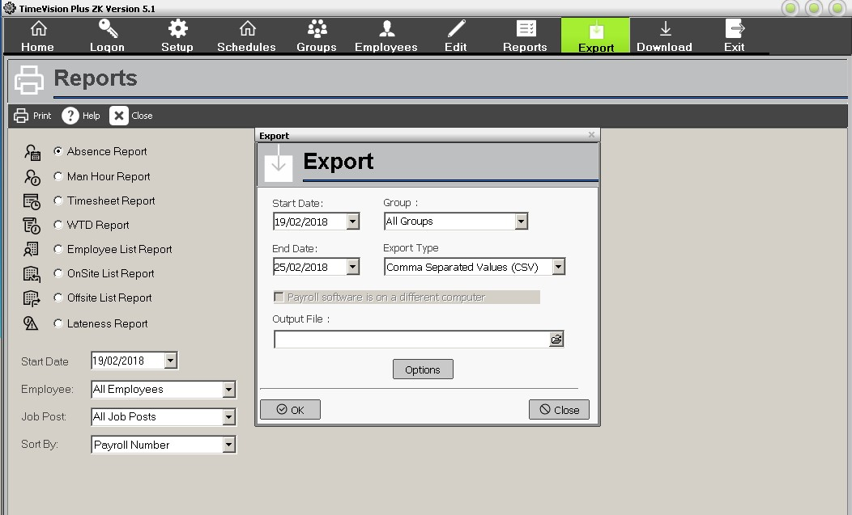

Here, you can specify the dates you wish to include. You can also specify
which groups should be involved in the file, and the file type.

If you have successfully installed our optional Sage Link, you will be able to transfer the working hours directly into Sage. (For more information on the optional Sage Link, please contact us.)

You can select where the report should be saved by finding the correct location in “Output File”.

You will need to give the file a name. When you’re done, simply click “OK” and the report will be saved to the location you specified with the name you have chosen.

Download:
To get the clocking data from the clock, you must first download it from the clock(s) to the software. This will depend if your clock(s) are setup on your network or not.
Networked. Click on the “Download button”
The software will then send a signal to the clock(s) and connect. Then it should download the data from the clock in date and time order, from the time of the last download.
USB. You first need to go to your clock terminal(s) and plug in a USB memory stick. Then download the attendance log to it. (separate instructions available from us, for each make & model of clock.)
Then plug the USB stick into a TimeVision Plus PC.
Click on the download button.
Click on the “Upload” button and browse to the USB stick and the location of the attendance log file.
Then click on download, and it should download the data from the USB into TimeVision Plus.

Import
If you have a lot of staff to add into TimeVision Plus, you can create a CSV file with all their details on. Then import it into the software by this wizard.

Remember to Exit the software when finished.

If you have any further questions relating to the use of TimeVision Plus, please don’t hesitate to email techsupport@computimeuk.com or call us on 0113 230 2002 and ask for Technical Support.

Common Errors

New Employee Can't Clock In
If you've just set someone up on the system and the clocking terminal is saying it doesn't recognize them, there are a few things to check:

- Is their user ID a unique number below 65,000? - The clocking terminals will not recognize a user ID higher than 65000.
- (Fingerprint) Is their user ID in the software identical to the user ID they were enrolled with on the clocking terminal (User Manager)? - If it isn't, change it so that they match.
- (Proximity) Is their card/fob number correct? - It should be the first long number on the back of the card/fob.
- Are there any leading zeroes in the user ID/card ID fields? - If there are, remove them. The software will already account for the leading zeroes.
- Is their Start Date/Card Valid From set to today? - If it is, change it to the day before you want them to start using the terminal.

Unable to Register Software
Is Port 20000 open on your PC & network? This port will need to be open for both TCP and UDP ports to allow the software to connect to our registration server.
You (or your IT) may need to allow it through Your Windows firework and other security software/hardware. E.g. Anti-virus software.

All Clocking’s Are Showing As 'In' Clocking’s
If all the clocking’s for an employee/group of employees are showing as being 'In' clocking’s, chances are there's an issue with the 'Latest Start' time within the schedule they've been allocated to.
'Latest Start' does not mean that if they clock in after that time, they will be marked as 'Late'.
What 'Latest Start' does is tell the system when they stop being on that shift. It means that if they clock in after that time, it will move them to the next available shift.
If the shift you're looking at is the only shift within their schedule, change the 'Latest Start' to 23:59 and this should resolve your issue.

Access Violation (& Network connection issues) When Downloading from the Clock.
If an Access violation occurs when downloading over the network, try to ping the Clock terminal.
- Open the command prompt
- Type ping followed by the IP address e.g. "ping XXX.XXX.XXX.XXX" and press enter
If it does not respond, ensure the terminal has power, check cables, and is currently connected to a network point. Also check that the terminal has the correct IP address assigned to it on the device, as in the TimeVision Plus/setup/setting screen.
If the terminal still does not respond even with the correct IP address, please ask your IT to look at the network connection between the clock and the PC.

If the terminal does respond please attempt to “Telnet” the device, this feature may not be installed and will need to be added from the "add windows features" option in the control panel. You will need to ensure the telnet client option is ticked.
Once installed open the command prompt and type "telnet XXX.XXX.XXX.XXX" where the X's are your clocks IP address. E.g. Telnet 192.168.0.123
If this comes up with a ZK log in prompt, then something is blocking the port your terminal uses for sending data.
If it does not come back with a log in prompt then there is an IP address conflict as a second device will have the same IP as your clock which your IT will need to fix or they will need to change the IP of the terminal.
If there is no conflict and it responds to a ping test, try to telnet the specific port for your terminal "telnet XXX.XXX.XXX.XXX 4370” e.g. Telnet 192.168.0.123 4370
where 4370 is the port number, if it does not respond to this then your IT need to open the port the terminal communicates in your Windows Firewall & other PC/Network security software/hardware, for TCP & UDP inbound & outbound Traffic.

Index Is Out of Date/Corrupt Index Header [Timevision Plus]

How to Fix Indexes Out of Date?
First close all copies of Timevision Plus
To fix indexes out date, use the tools program:
Right click the TimeVision Plus desktop shortcut.
Select “Open File Location.”
Double click on Pttools or TaTools folder.
Right click “Tatools” and select run as Administrator.
Click on “OK” on opening screen.
In the tools click the Re-Index button.
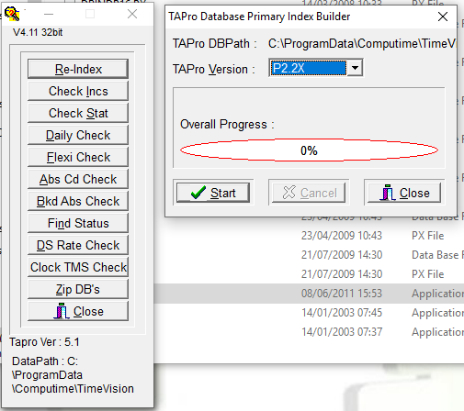
Ensuring that version 2.2x is selected, on the next screen. It should also show the correct database path. (If not contact support.) Click on Start.
It will run 2 cycles one (Green, then red.)
If "re-index complete” Ok. Close.
Then run TimeVision Plus and do a download again.
If an error occurs or the software still says index out of date after a re-index please contact support on 0113 230 2002 or by email: techsupport@computimeuk.com
Access Violation when downloading
This is usually caused by something missing or incorrect in the Employee’s details (Usually the recent one added or amended.) Save all changes and update clock(s).
- Check there is a UserId number. This has to a unique number below 65,000 with no leading zeros and letters.
- If proximity terminal, the RFID Card number, must not contain any leading zeros or letters. Usually 7 or 8 characters in length.
- There is a Payroll number, and name and start date, entered.
- No duplicate entries.
Invalid Terminal Type
In TimeVision Plus, version 5.2, you can have various make & models of Clock terminals. In Setup\setting, ensure you have entered the correct type of terminal in the Terminal Type pull down menu. ZK, Anviz, and UK. Plus select the right tick box for Proximity, Face or Finger terminal. If it doubt check with support. Save all changes.

26

