

TimeVision User Guide
Version 5.2

Main Menu

When you first launch TimeVision, you’ll be greeted by the following screen.
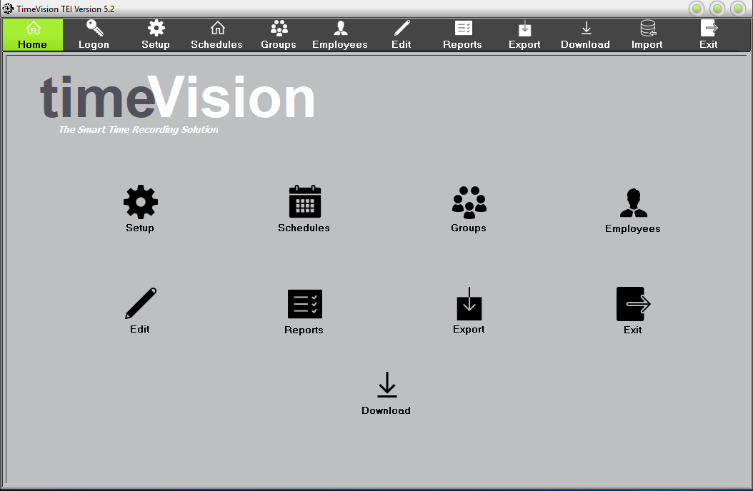

Along the top, you’ll see a series of icons:

- These icons each have different functions, listed below (from left to right):

- Logon/Logoff – This allows you to log on or log off.

- Setup – This allows you to configure TimeVision’s setup and gives you the ability to backup and restore data.

- Schedules – This allows you to configure shifts for your employees, and specify their start time, finish time and breaks, etc.

- Groups – This allows you to assign any schedules you have created to your employees.

- Employees – This allows you to create, edit and/or delete any employees on your database.

- Edit – This allows you to view when employees clock in/out, the day and date, what rate they are being paid for their hours worked, and any error codes or anomalies.

- Reports – This allows you to view several reports based on the data gathered (e.g. “Absence Report”).

- Export – This allows you to export the clocking data into a CSV file or directly to your Sage payroll system.
- Download – This allows you to Download data from the Clocking Terminal, to Time Vision, either across the network or by USB Stick.
- Import- This allows you on setup to import new Employee data from a CSV file.

- Exit – This will exit the application.
You can select these options by clicking on these icons across the top, or the select icons on the main home page.

To log in to TimeVision, click the “Logon” button.

This will take you to the following screen, where you will need to select your TimeVision username in the “User Name” list, and then type your password in the “Password” field. (Not your windows Logon credentials.)

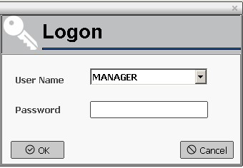

By default, the username is “Manager” and there is no password. We recommend you change this ASAP for security purposes and to avoid unwanted changes to your data.

Setup

This is where you can make changes to the TimeVision software. The first section is “User Setup”.
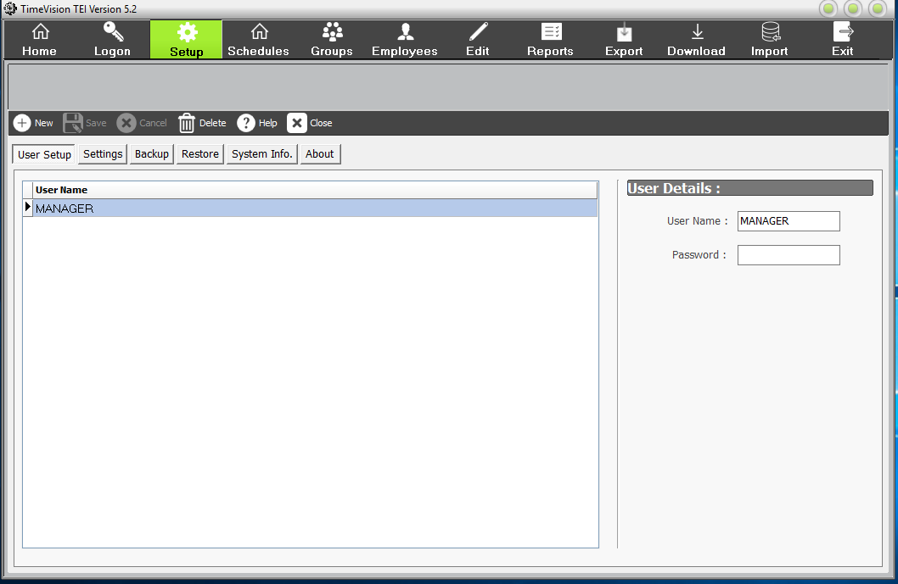
This is where you can add and remove users from the system. All users will have the same level of access within TimeVision.
If no users are defined, everyone can use the system and change the data, so it’s highly recommended that at least one user is defined for security reasons.

When assigning a password to a user, the password length is limited to 10 characters, but can include a mixture of numbers and letters. Please note that passwords are case sensitive.

The next section is “Settings”.
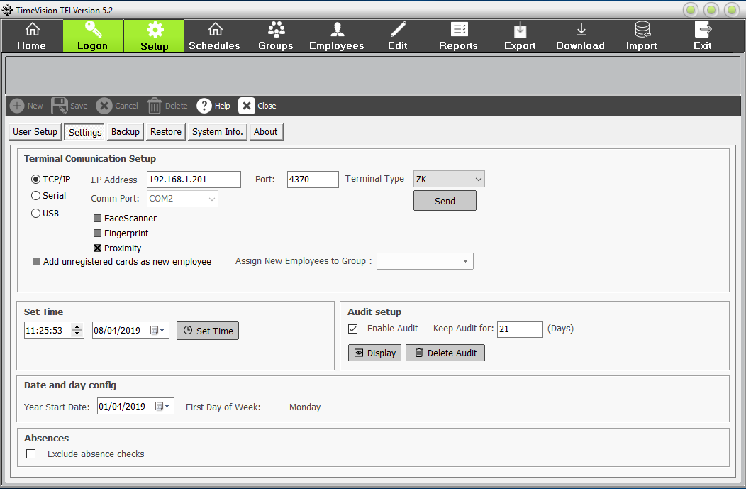

“Terminal Communication Setup” will allow you to add a clock to the system (though this should already have been done for you). There are 3 ways of doing this – through TCP/IP, Serial or USB:

- TCP/IP – This allows the clock to be accessed over a network. The default IP address is 192.168.0.201, and the default port is 4370.

Your IT should assign you a free static IP address for your network. This needs to be same on the clock terminal and in TimeVision.

- Serial – This allows the clock to be connected directly to the PC via a RS-232 cable. If this is the method used, you will need to select that the COMM Port is being used. (Used for old Clock terminals).
- USB – Data is transferred from the clock to the PC & TimeVision, by a USB memory stick (pen drive), when there is no network connection.

You also need to select the correct clock type from the pull-down menu. (ZK, Anviz or UK), as TimeVision can deal with different make & model clock terminals.

Select Face scanner, Fingerprint or Proximity terminals, by selecting the relevant tick box.

Leave the Add unregistered cards as new Employee field, blank unless we tell you otherwise.

Then Save these settings.

If your clock terminal is connected across the network, you can update the information on the clock using the ‘Send’ button.

You can also “Set Time”. This will change the time and date of the clocking terminal, if networked. This will take the time from the PC, when this screen was opened. (if this screen is open for a while, the time will be wrong). You can amend the date and time manually.
This is a good way to check you have a network connection with your clock terminal.

“Audit Setup” will allow you to create audit files – these will give details of any changes to the system, e.g. editing data, entering the setup screen. The audit will enable you to keep track and monitor which buttons and options have been enabled. If you have defined System Users, the audit will also show who was logged in at the time. If you do not wish to record this data, uncheck the “Enable Audit” box.

Clicking “Display” will bring up the audit report if “Enable Audit” is checked. The information in the audit includes:

- The time the action took place.
- The computer used when the action took place.
- Which user performed the action.
- The action, e.g. “clicked on Logon button”

If you wish to keep an audit, from here you can specify how long the recorded data should be kept for. You can also display an audit or delete any currently stored audit data.

You are also able to configure the “Date and Day”. This will default as the day the system was installed but can be changed. It will also affect which day the system considers to be the first day of the week. We recommend you change this to reflect the first day of your working week.
Absences:
If you wish to exclude Absence checks (ABS) from the list of errors, tick this box, here.

The next section is “Backup”.

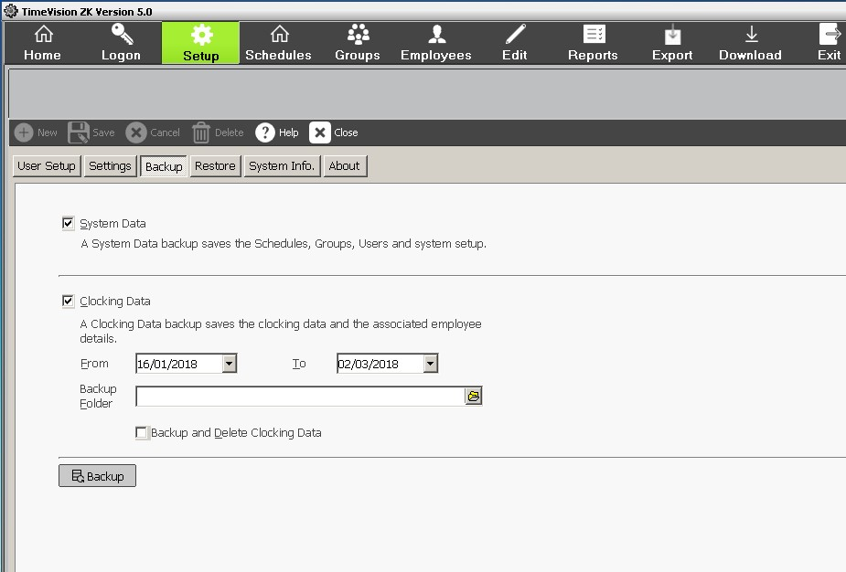

This allows you to save a copy of your data that can be used later to recover any lost or corrupted data.

Important: You should backup your data on a regular basis in case of any problems that could corrupt or destroy your data. This backed up data can easily be restored using the ‘Restore’ function within TimeVision.

There are two different types of backup that are supported by TimeVision;
‘System Data’ and ‘Clocking Data’.

- “System Data” will create a backup of your schedules, groups, registered users and your general system setup which will be saved to the specified folder.

- “Clocking Data” will create a copy of all of your clocking data (between two specified dates) and any associated employee data which will be saved to the specified folder.

Important: We recommend storing any backup data on a removable media such as CD, USB stick or a network drive. It is also advisable that a copy of your backup should be taken offsite regularly in case of fire or theft.

The “Backup and Delete Clocking Data” option will allow you to back up the clocking data and then delete it from the current data. (This data can then be recovered at any time using the “Restore” option).

To back up your data, all you need to do is click the “Backup” button.

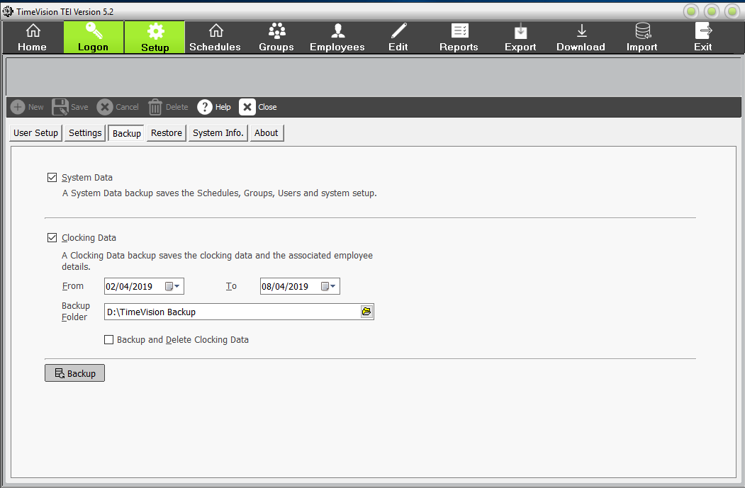

You can also manually backup the TimeVision data, in Windows (file) Explorer as follows:
- Browse to the TimeVision Database.
Usually at C:\program data\computime\timevision\data.
- Copy the whole of the data folder.
- Then paste the data folder elsewhere (e.g. network drive, USB drive, etc.)
- Rename this folder, e.g. TimeVision Backup 090419
- Browse to the virtual store for the user. (if it exists)
C:\Users\”User”\AppData\Local\VirtualStore\ProgramData\Computime\timevision\data
- Copy the whole of this data folder too, as you need both data folders.
- Paste this “virtual” data folder to the same location as the main data folder.
- Rename this folder e.g. TimeVision Virtual backup 090419
- You need the data backup folder and if it exists, the virtual data backup folder, to restore all the data, as the virtual data folder, may contain more up to date data for some of the database tables. E.g. clock and employee data.

The next section is “Restore”.
This allows you to retrieve any previously backed up data. This is mostly used in case of data corruption, or if any data is lost.

“Restore Folder” allows you to tell the system where the backup you saved is kept, so you can restore the data saved in the backup.

This allows you to select which data should be restored. If you have configured your Restore Folder correctly, the dates should have already been put in for you, though they can be edited as required.

To restore your data, all you need to do is click the “Restore” button.
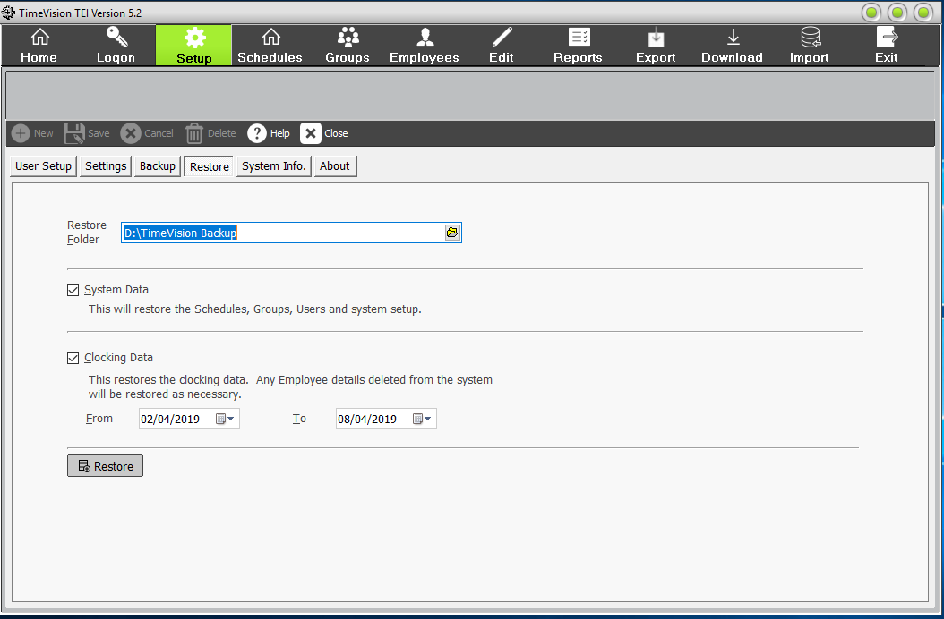

The next section “Bells”, only appears if your TimeVision is licenced for this optional module.

Bells Timer

Both TimeVision & TimeVision Plus, can support a Bell system that is wired into and controlled by their Clocking Clocks. For information on the bell wiring for the clock, see the documentation for your model clock.
Bell Timer is optional. The “bells” licence option needs to be included in your software licence. A new tab “Bells” will then appear in the Setup menu.
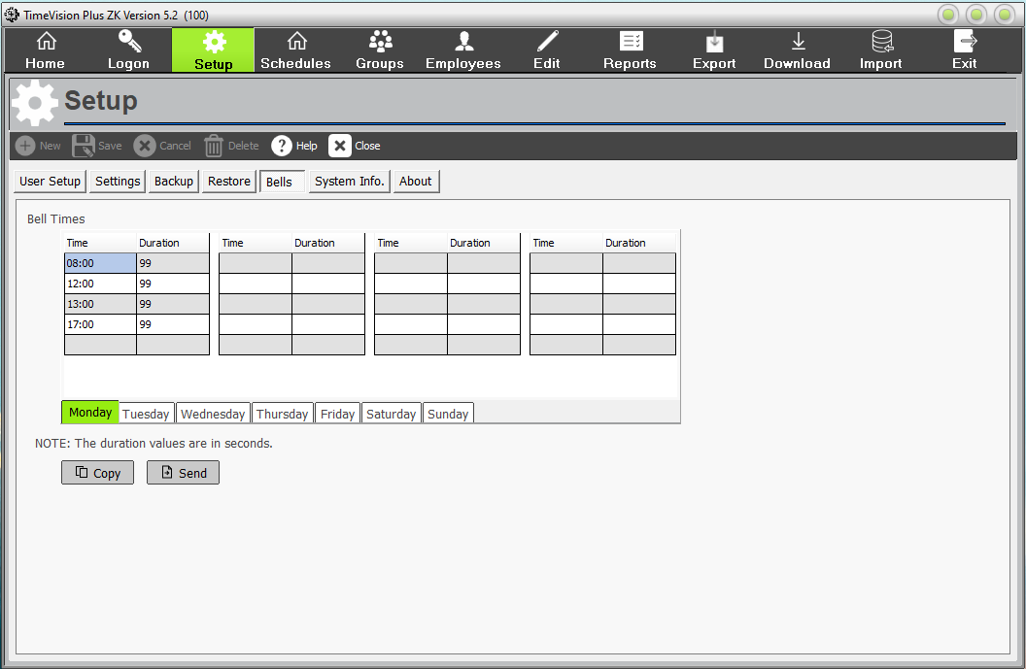

To set up or amend the bell times.
- In the Time Column, Key in or amend the time using the 24-hour clock. E.g. 08:00
- Then in Duration Column, enter the time in seconds you wish the bell to ring for. (Maximum 99 seconds).
- Then save.
- Repeat for other Bell times.
- Click on the “Copy” button, to copy the current day, to the other days of the week. Save.
- Click on the “send” button to send the Bell times to the clock(s).
- If a clock supervisor, you can also check the bell times on the clock. On ZK clocks menu, it is under personalize\bell times.

The next section is “System Info.”
This contains the data path, network settings, and licence information.
The “Get Licence” button is used to update the TimeVision licence, online. if you change your employee limit or purchase the optional Sage Payroll link.
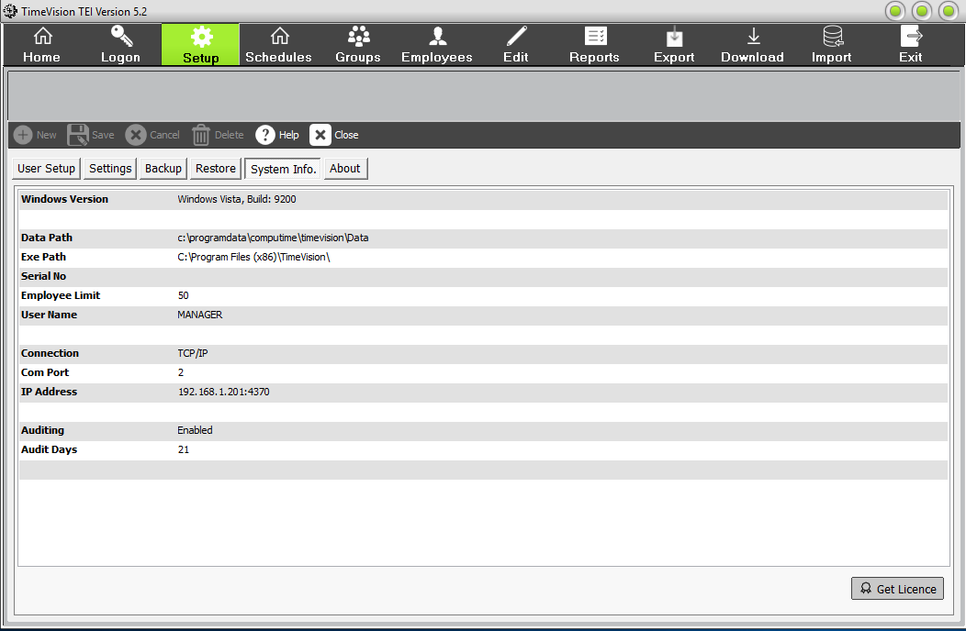

The next section is “About”.
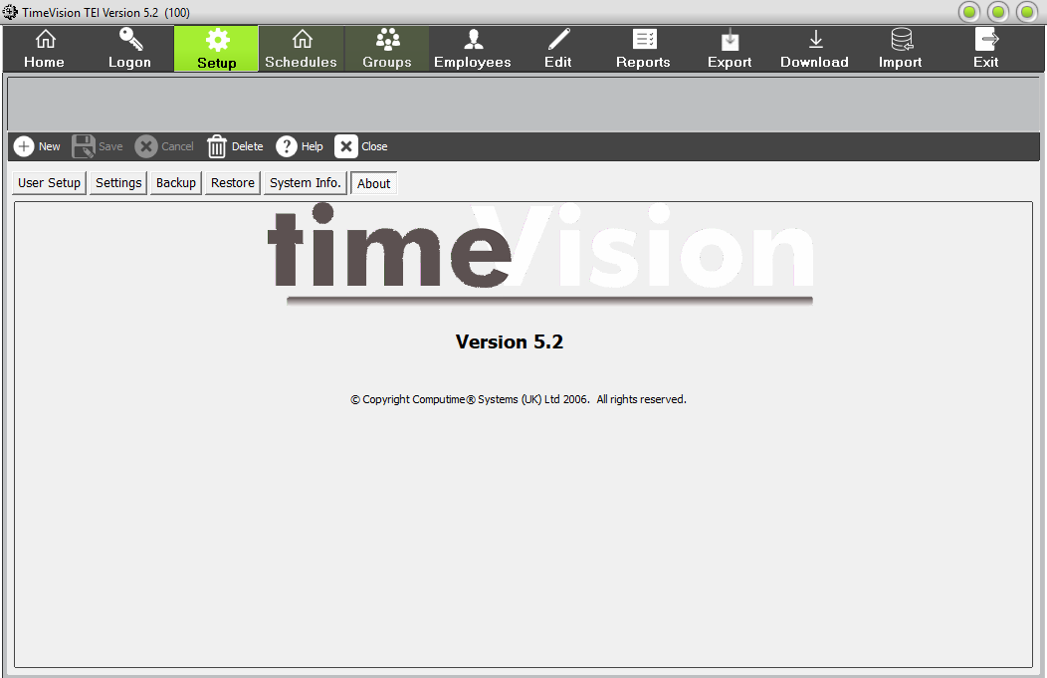

This tells you which version of TimeVision you’re currently using. If you contact the Support department, you will be asked for this information.

Schedules
Schedules are work patterns or shifts that are regularly worked by all or some of your staff. E.g. 09:00 to 17:00, 14:00 to 22:00.

To begin setting up shifts for your employees, click “Schedules” from the main menu. Then select “New” to start a new schedule or select an existing schedule from the pull-down list. In TimeVision, you can have 10 schedules.
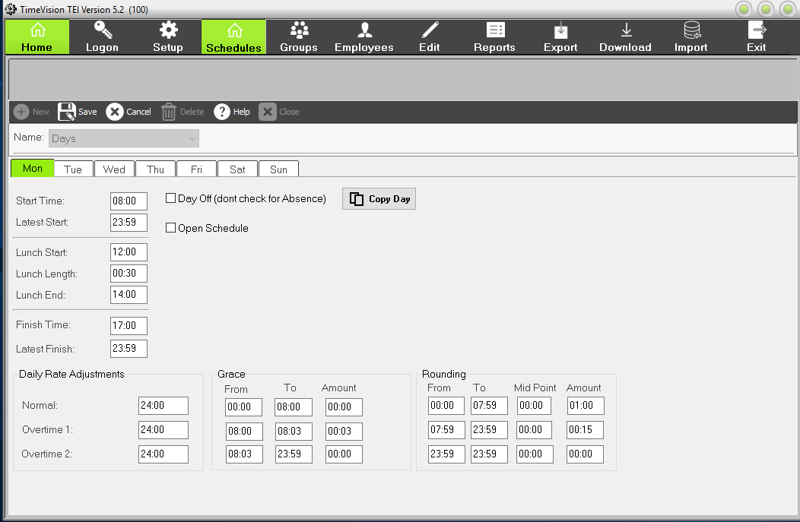

The “Start Time” and “Finish Time” allow you to specify when you would like the employee’s shift to start and finish. If they clock in after the time specified, they will be marked as ‘Late’ on the report.

The “Latest Start/Finish” field means that if the employee clocks in/out after the specified time, they will be moved to the next available shift. E.g. Start time: 08:00 and Latest Start: 08:30. Then if Ian starts today at 09:00, he will put on the next shift. Therefore, if the employee only works one shift a day, it’s recommended that the Latest Start/Finish value remains at 23:59.

The “Lunch Start” and “Lunch End” fields allow you to specify when the employee’s lunch break should start and end.

The “Lunch Length” field allows you to specify how long the employee’s lunch break should be. This means that if the employee does not clock in/out for lunch, the lunch length you have specified will be automatically deducted from their hours worked.

If an employee clocks in/out but takes longer than the allocated lunch length, the actual time they were clocked out for will be deducted.

“Grace Bands” allow you to specify times when an employee is allowed some leeway when clocking in.

For example: An employee may have a start time of 08:00, but if they clock in up to 08:03 you still want to pay them from 08:00. This would be a grace band running from 08:00 to 08:03, of amount 00:03.

“Rounding” allows you to specify how you want your rounding to occur. When an employee clocks in, it will automatically round up – and when they clock out, it will automatically round down.

You can define three different bands throughout the days with differing rounding bands, as shown above. If you wanted to only pay your employees in 15-minute intervals, an example of how rounding works would be that if they clocked in at 08:05, it would round up to 08:15.

“Daily Rates” are used in defining how the hours worked in a day are split.

For example: If you wanted to pay the first 7 hours at Normal rate, the next hour at Overtime 1 and the next two hours at Overtime 2 – you would set Normal to 07:00, Overtime 1 to 01:00 and Overtime 2 to 02:00.

“Day Off” allows you to record when an employee is not expected to work. E.g. Saturday.

This should not be checked if an employee is absent – this function is specifically for when the employee has a day that they are not scheduled to work.

“Open Schedule” allows you to create a schedule with no fixed start time, for that day only.
This means that an employee can never be flagged as late, because clicking ‘Open Schedule’ means that the “Start Time” and “Latest Finish” boxes will be disabled.

Night Shifts (including shifts that go beyond midnight (next day))
To record shifts that go beyond midnight into the next day, we had added 24 hours to the Finish times.
For example:
Night shift from 10pm to 8 am, next morning. Would be recorded as:
Start Time: 22:00
Finish Time: 32:00 (8 hrs + 24 hrs).

Once you have done the first day, you can copy that day, to some or all the remaining days of that week, by clicking on the “Copy Day” button.
When finished, remember to click on the “Save” button.

Groups
Groups consist of one or more schedules that a selection of staff work on a regular basis. E.g. Production 06:00-14:00 & 14:00-22:00 schedules.
These groups can then be assigned to your employees. It’s also possible to specify weekly overtime rules for individual groups
To begin setting up groups for your employees, click “Groups” from the main menu. Then select “New” to start a new group or select an existing group from the pull-down list. In TimeVision, you can have 10 groups. You need at least one schedule created, before you can do your first group.
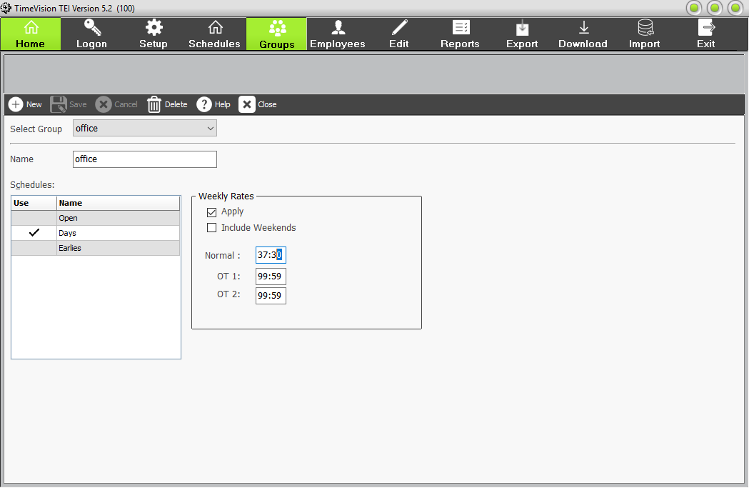

For example: If an employee must work 37½ hours in a week before they can earn overtime, this can be arranged through the weekly overtime rules. It is also possible to specify whether any hours worked at the weekend can be used to make up for any shortfalls in weekday hours.

To set up a new group, click “New”.

Here, you’ll be able to name your group (e.g. Production) and select which shifts (e.g. Earlies & Lates) you want to be a part of it. You’ll be greeted with a list of shifts you created before, as seen below:

To select a shift to be assigned to the group, click in the “Use” box next to it. You can also change the “Weekly Rate Adjustment”. If you want to set specific rules for this group (e.g. if you want them to have to work for 40 hours in a week before they can earn 6 hours of overtime), you’d set “Normal” to 40:00, then “OT 1” to 06:00. You can also specify whether you’d like to include weekends or not.
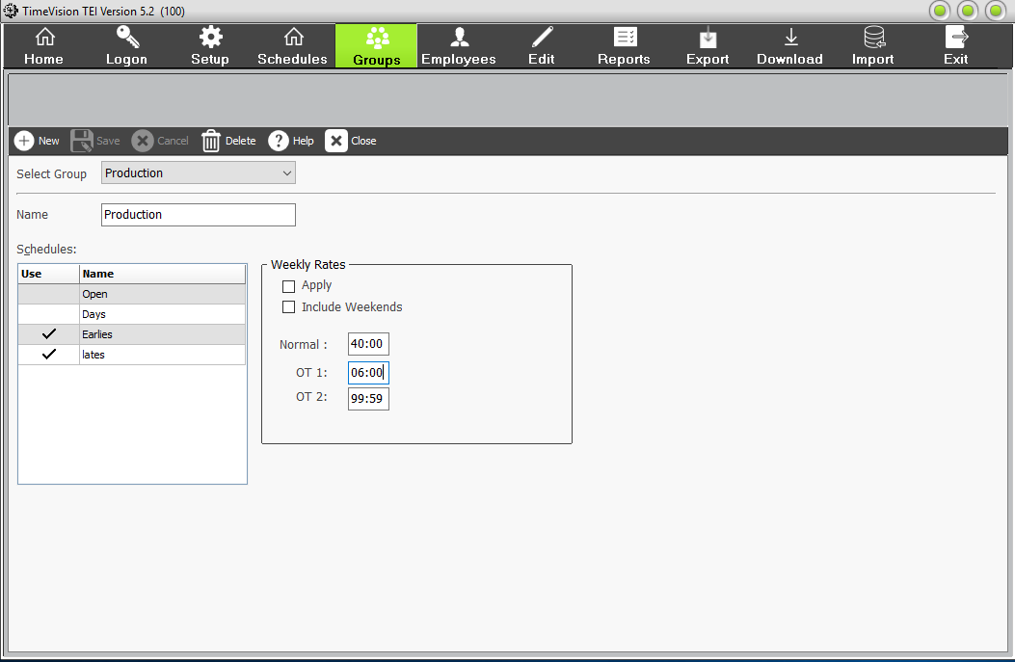

When you’re done making changes, click “Save”. The new group you have assigned will now be shown – clicking on it will show you which schedules are currently assigned to that group.

Employees
Now that you’ve configured the shifts and groups for your company, it’s time to assign these groups to employees. Start by clicking “Employees” from the main menu.

If you need to add a new employee to your database, click “New”.
Then add the following information, for each employee:
- Payroll Number *
- Initials *
- Surname *
- UserId Number *
This must not contain any leading zeros or letters and be below 65,000. It must be unique (It can be the same as the payroll number)
- RF Card ID (Compulsory if using Proximity Clocks)
This is usually the first group of numbers on the RF card or Fob. Drop any leading zeros. E.g. “00012345” should be entered as “12345”
- Password (optional)
Enter a code of 4 numbers. Then the employee can clock in or out with their UserId number and password.
- Start Date *
This needs to be a date of yesterday or before, if you want to use the card immediately. As changes happen at midnight.
- Group *
Enter the group, from the pull-down list.
- If you use a face scanner, it can put their photo here. Alternatively, if you have their photos on file, you can browse to it, and it will appear here.
- If an employee leaves, mark them as a “leaver”. Their date will be still be accessible, and they will not count towards the employee limit.
- If there are to be a clock terminal supervisor, tick here.
* Compulsory fields.

The boxes near the bottom of the employee section, are if you wish to use the EC Working Time Directive (WTD) for that employee. There is a report option in Reports for this.
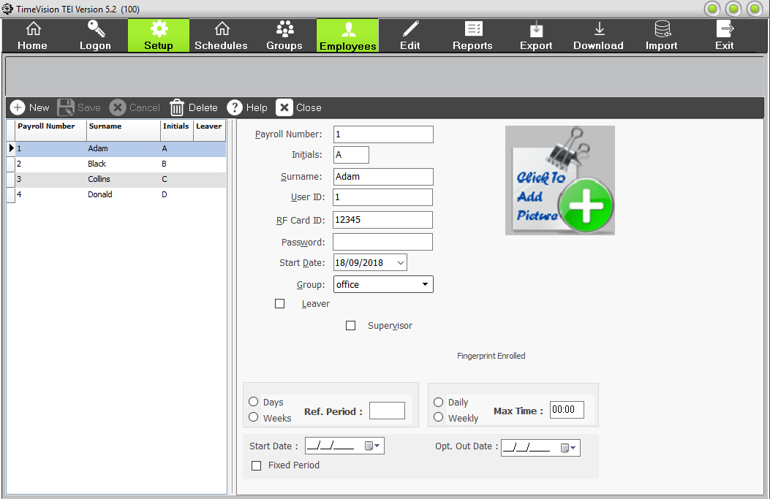

Edit Data
To review the clocking data downloaded from your clocking terminal (and make any necessary changes), click “Edit” from the main menu.
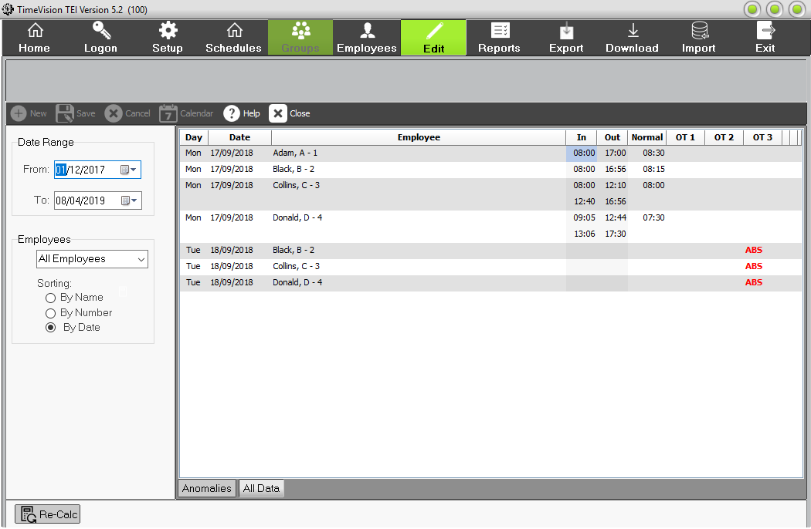

This section allows you to view and edit data downloaded from the clocking terminal. You can amend the clocking times and hours worked for a day, and/or change codes used, e.g. ABS to SIC, or remove a LAT code.

By default, this screen will show the last seven days’ worth of clocking data, but you can change which dates are shown by using the “Date Range” on the left. You can also filter the data further to view a single employee, or group employees shown by Department and/or Job Post.

There are two main pages on this screen: Anomalies and All Data.

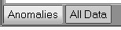

The ‘All Data’ page shows all clocking data for the dates/employees selected.

The ‘Anomalies’ page will only show days with anomalous clocking’s (e.g. employees flagged as late, absent, those who haven’t clocked out).

If you highlight an anomaly on the ‘Anomalies’ screen and click “Accept”, this anomaly will be removed from the Anomalies page. It will, however, still be viewable from the ‘All Data’ page.

After amending any clocking data, press “Re-Calc” and the system will recalculate that selected employee’s Normal/Overtime hours for the highlighted day.

Reports
There are Eight types of reports offered by TimeVision:
Each will allow you to enter filters:
Date range
All or individual employees
All or individual groups
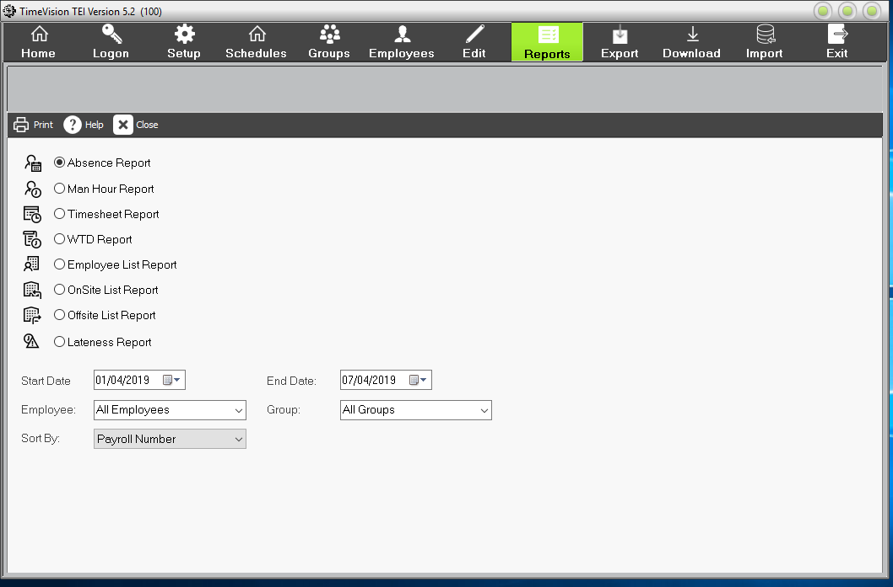

- Absence Report – This allows you to print a list of absences between two dates for a range of employees. (This will cover four different types of absence – Holiday, Bank Holiday, Sickness and Absence). You can specify which type of absence you wish to be printed on the report.

- Employee List – This will allow you to print a list of the employees defined in the system. You can print an individual group or all employees.

- Man Hour Report – This will allow you to print a list of employees and the total hours worked by each employee.

- Onsite / Offsite List – This will allow you to print a list of all employees who are showing as being onsite or offsite. (Important: Please note that TimeVision is not a real time system and will only show the status at the time the clocks were downloaded).

- Timesheet Report – This will allow you to print a timesheet for the selected employees. The timesheet will provide a list of the clocking times and hours for each day.

- Lateness Report – This will allow you to print a list of lateness’s within a specified period.

- WTD Report – This will allow you to print a report of the average number of hours an employee has worked as set up on the Working Time Screen.

To print a report, you need to select the one you require (by clicking on it) and, if necessary, specify the dates of the report. You can also specify which employees or groups should be included in the report and can choose how to sort the employees in the report. Depending on the report, you may have additional options to select afterwards. E.g. Absence report.

When you’re ready to print the report, click “Print”. This will enable you to see a print preview and configure where and how the report should be sent.
If you want to select a different printer to the default one, click on “Setup” You can select a Windows printer that is setup on that PC.
Note if you wish to keep an electronic copy of the report, best to select to print to PDF/XPS/One note document.

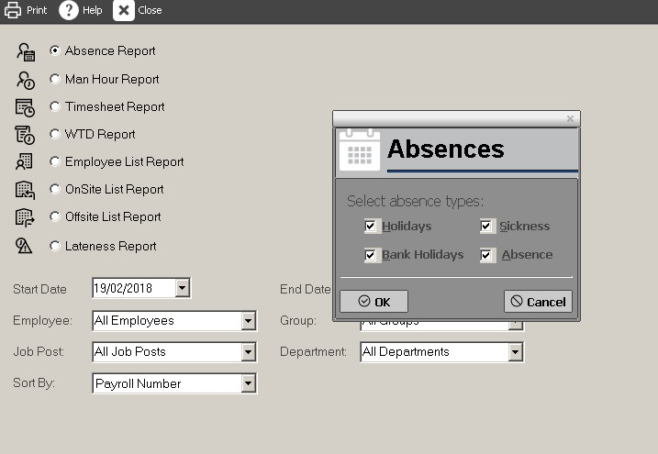

If you want a physical copy of the report, click on Ok” then on Report
Destination clicks on Printer. This will send it to the selected printer (in this case is Samsung ML -331).

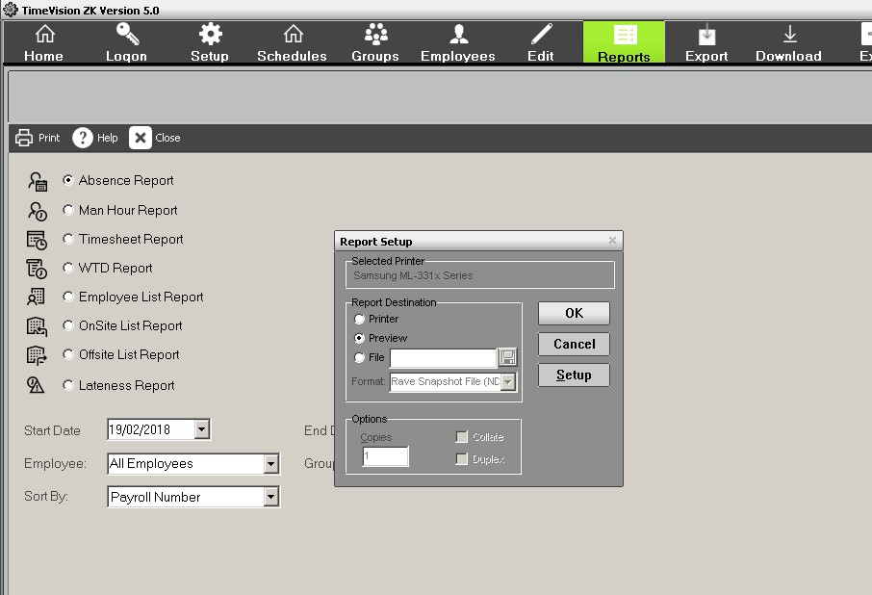

Export
The “Export” feature allows you to generate a CSV or Sage payroll file (if you have the Sage payroll software installed). In order to generate one of these files, you need to click “Export” from the main menu.
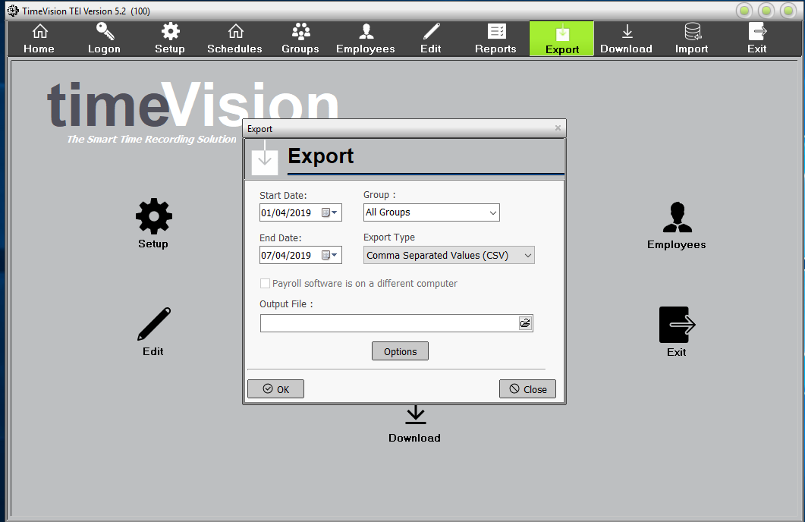

Here, you can specify the dates you wish to include. You can also specify which groups should be involved in the file, and the file type.

If you have successfully installed a Sage Link, you will be able to transfer the working hours directly into Sage. (For more information on the optional Sage Link, please contact us.)

You can select where the report should be saved by finding the correct location in “Output File”.

You will need to give the file a name. When you’re done, simply click “OK” and the report will be saved to the location you specified with the name you have chosen. This will be a CSV file, which can be converted to an Excel document, and some third-party payroll software can import these CSV files.
The CSV file shows for the date range, and groups selected, the employees UserId number and the total hours worked at each rate for that period.
e.g. Fred blocks worked the first week of April, 35 hours at basic, and 6 hours overtime. That is: 5, 35, 6

Download


This allows the program to connect to the clocking terminal in order to collect the clocking data stored on it. We recommend you do this at least once a week because terminal failure may result in data loss. Additionally, the more data that needs to be downloaded, the longer time it will take.

Depending on how you connect to your clock terminal, will depend on the method used to down the data from the clock.
Network (ethernet) connection
Click on the Download Button, and the software will connect to the clock terminal over the network. It will do a few checks first, then collate the information, and then start downloading the clocking data from the time of the previous download. Depending on the when the last download was, number of employees, network & PC speed, etc., this may take a while. Then it processes the transactions, then it will check for absences. You will be told to click on the “Close” button when done.

USB Download.
You first need to extract the clocking data (attendance log) from the terminal, to a USB stick (pen drive.) The method depends on the make and model of your Clock terminal you have, and separate instructions are available from Computime. The USB stick must not be encrypted, locked or password protected, and be in FAT32 format, and less than 8GB in size.

- Once you have the clocking data on your USB stick, please plug it into a USB port on the PC with TimeVision installed.
- Click on the TimeVision Download Button.
- In the Download USB Clockings window, click on the “Upload” button.
- Browse to the USB Drive, and click on OK.
- This will add the download date & time, when the download was done from the clock terminal, that is on the USB stick.
- Click on the “Download” button.
- The download will start shortly afterwards.

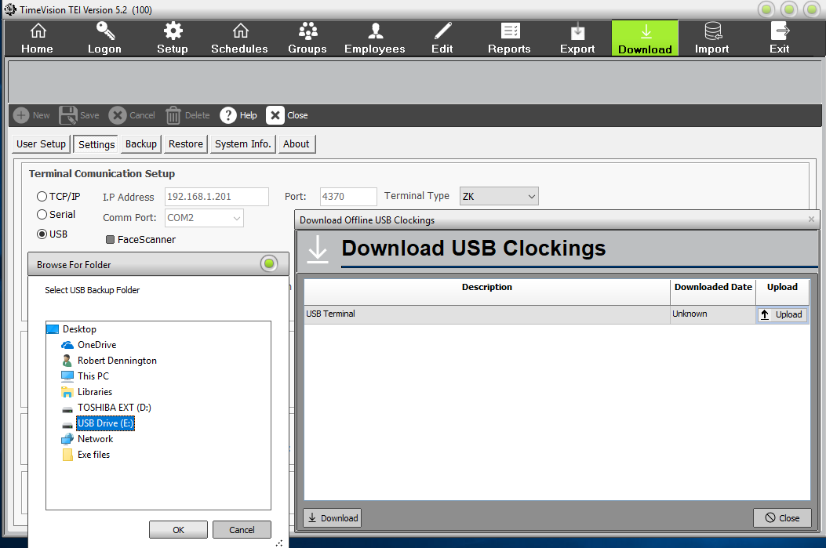
You can check the downloaded clocking data, by going into the Edit section.

Import

If you have a spreadsheet (CSV File) of your employees, containing the correct information and in the right format, you can import this information directly into TimeVision, by using the import tool. These fields are:
Payroll No, Surname, Initials, Start Date, Password, RFCard ID, Group, Supervisor, User ID
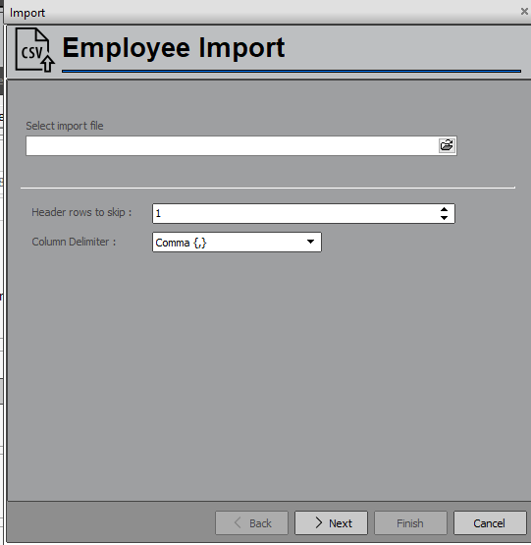

Exit

When you have finished using TimeVision, do not forget to Exit the program.

Common Problems
Unable to Connect to the Clock terminal.
- Check the clock is switched on.
- Check that the IP address of the clock is the same as in TimeVision (Settings/setup).
- Check that the network cable is securely attached at both ends and is not damaged.
- Can you “ping” the clock’s IP address, at a command prompt?
- Check the Windows Firewall is not blocking access to the Clock terminals port number, for TCP & UDP Traffic, in and outbound. Usually port 4370.

Getting Index errors or corrupt file.
- Right click the TimeVision Desktop shortcut and select “Open file Location”.
- Double click on the “tvtools” folder,
- Right click on “tatools” application, and select “Run as administrator”
- Run Tatools utility program
- Select Re-index
- Select version 2.2x, then click on start.
- Any errors contact Tech support, at computime.

Get Access violation errors on download.
This is usually caused by one or more employees having compulsory data missing from their details or is incorrect. Usually the UserId field. Check any recent changes to employees.

Why am I getting ‘NSS’ for an employee?
NSS stands for ‘No Shift Selected’. There are two possible reasons why this anomaly has been generated:
1. You have set up a new employee and have forgotten to assign them to a group.
2. You have more than one schedule in a group, and they have clocked after the latest start time in the last schedule in the group; as a rule, you should always set the latest start time of the last schedule to 23:59.

Why am I getting absences for days employees are not supposed to work?
Ensure you have put a tick in the ‘Day Off’ box for each day that you do not wish absences to be checked for, e.g. Saturday & Sunday.

If you have any further questions relating to the use of TimeVision, please don’t hesitate to email techsupport@computimeuk.com or call us on 0113 230 2002.

