TimeVision/Time Vision Plus Installation & Setup.
(NB. Also Protime, which is an earlier version of TimeVision Plus, before it was rebranded)
- You will need the installation software CD, or electronic download. Ensure if this an additional installation of TimeVision Plus, it is the same version, as the other installs.
- From the installation software, browse to Setup.exe. Then right click and from the pull-down menu, select “Run as administrator”.
Click on “Yes” if asked, to run program.
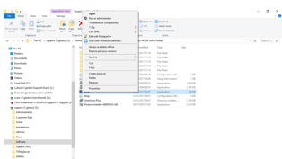
- Follow the on-screen instructions, including accepting the software licence, and default program destination & database paths, etc.
Click on “Finish” when done.
- Then you need to create a desktop shortcut, as follows:
Browse to C:\Program Files (x86) \TimeVision (or TimeVision Plus).
Right click the application e.g. Timevision.exe and select Sent To/Desktop (create shortcut).
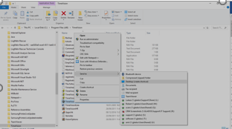
- For TimeVision & TimeVision Plus with the Database on the local PC (Non-networked), it is best to run the software as a local administrator.
So right click the desktop shortcut, and from the pulldown menu, select properties.
- Then select the Compatibility Tab.
Click on the “Change Settings for all Users.” Button.
See screen shot below.
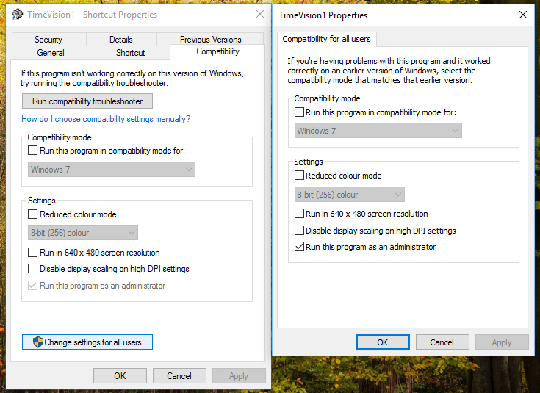
- Put a tick in the “Run this program as an administrator” box.
Then click on “Apply” and “OK”.
- You will be then taken back to the previous window.
Run this program as an Administrator should be greyed out.
Click on “OK” to finish.
- Next time you run TimeVision/TimeVision Plus, it should then run as the local administrator.
You may be asked to say Yes when opened, to allow application to make changes….
- You may get a dongle error message when running earlier versions (< version 3) of TimeVision/TimeVision Plus, as below.
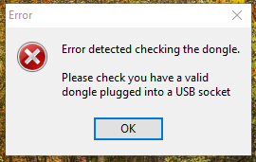

- Right click the desktop shortcut, and select properties from the pull-down menu.
Select the shortcut tab.
In the target field, at the end after the application path, add “/nodongle”
then apply and OK.
See screenshot.
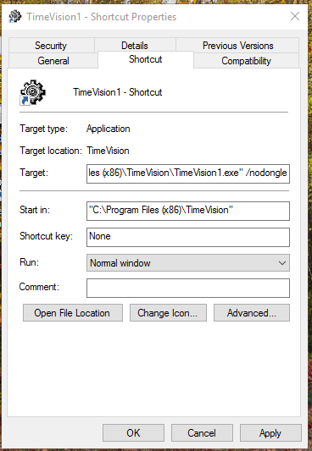

- If you are running a 64bit version of Windows, and running version 4 or below of this software, you will need to make registry changes to the PC. (Version 5+ should do these changes for you, automatically but if not follow these instructions also).
See separate document – “64 Bit Registry changes for Time Vision/TV plus.”
- When you run the software for the first time (& if there are any changes to the PC/user/software), it will need to be registered online.
If you cannot register online, you will need to do it manually by clicking on the “Fax” button. Then fax or email a copy of this form, to techsupport@computimeuk.com

- When you login into the software, there is no password set for Manager, until one is set by you. So just click on “OK”.
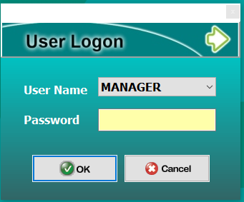
- The first time you use TimeVision/TimeVision Plus, you need to configure the clocking terminal or terminals (only TimeVision Plus can have more than 1 clock).
Go into Setup, then Setting. Terminal Communication Setup.
Select the communication method.
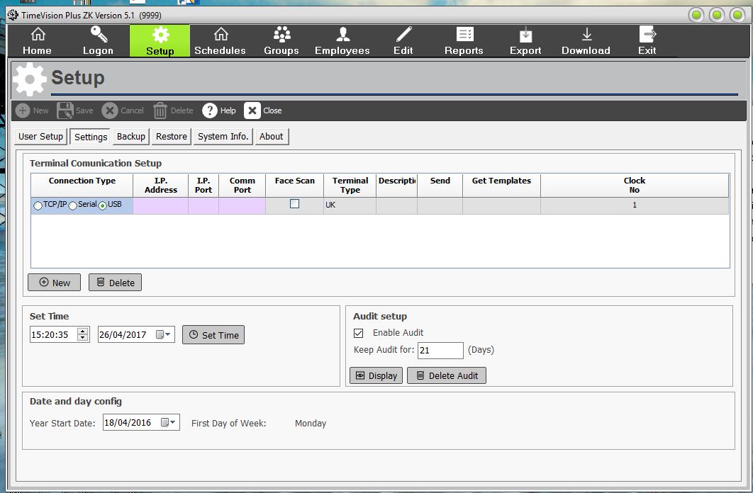
By USB. - Memory stick (Not available for Hand scanners and Multi-Tek clocks)
or by TCP/IP. Usually over an ethernet network (Not Wi-Fi) or Crossover cable, using a unique static IPv4 addresses (Not DHCP).
The same static IP address must be input into the clock(s).
- Set Year start date (usually a Monday). E.g. 02/01/2017.
- You can test a TCP/IP connection to a clock, by sending the Time to it, via “Set Time”.
You can also ping & telnet the clock from a command prompt.
If it fails there is a problem with the network connection or clock setup.

- Save when finished, then close.

- Time Vision is installed on one PC, and its database is usually at C:\ProgramData\Computime\TimeVision\data
Its database cannot be networked or shared.
- TimeVision Plus can be installed either on a standalone PC with its database local e.g. C:\ProgramData\Computime\TimeVision Plus\data or networked. See separate document.
- Also see the user guides for the software & clocks.

